Message in a Bottle: Archived DNA Reveals Marine Heatwave-Associated Shifts in Fish Assemblages

Zachary Gold1,2*, Ryan P. Kelly3, Andrew Olaf Shelton2, Andrew R. Thompson4, Kelly D. Goodwin4,5, Ramón Gallego2, Kim M. Parsons2, Luke R. Thompson5,6, Dovi Kacev7, Paul H. Barber8

1 Cooperative Institute for Climate, Ocean, & Ecosystem Studies, UW, Seattle, WA

2 Northwest Fisheries Science Center, NMFS/NOAA, Seattle, WA

3 School of Marine and Environmental Affairs, UW, Seattle, WA

4 Southwest Fisheries Science Center, NMFS/NOAA, La Jolla, CA

5 Ocean Chemistry and Ecosystems Division, Atlantic Oceanographic and Meteorological Laboratory, Miami, FL

6 Northern Gulf Institute, Mississippi State University, Mississippi State, MS

7 Scripps Institution of Oceanography, UCSD, La Jolla

8 Department of Ecology and Evolutionary Biology, UCLA, Los Angeles, CA

*Corresponding author Email: [zachary.gold@noaa.gov](mailto:zachary.gold@noaa.gov)

**Abstract**

Marine heatwaves can drive large-scale shifts in marine ecosystems, but studying their impacts from a species assemblage perspective can be difficult. Here, we leverage the taxonomic breadth and resolution of DNA sequences derived from the ethanol of a 23-year longitudinal sample collection, combining these with microscopy-derived ichthyoplankton identification to yield higher-resolution species-specific quantitative abundance estimates of fish assemblages in the California Current Large Marine Ecosystem during and after the 2014-16 Pacific marine heatwave. This integrated dataset reveals patterns of tropicalization with increases in southern, mesopelagic species associated and declines in important temperate fisheries targets (e.g. North Pacific Hake (*Merluccius productus*) and Pacific Sardine (*Sardinops sagax*)). We observed novel assemblages of southern, mesopelagic fishes and temperate species (e.g. Northern Anchovy, *Engraulis mordax*) even after the return to average water temperatures. Our novel modeling approach opens the door to reconstructing the historical dynamics of assemblages from modern and archived samples worldwide.

**Introduction**

Climate-induced marine heatwaves (MHWs) are increasing in frequency and severity with far-reaching consequences in marine ecosystems (*1*) ranging from severe organismal stress to cascading ecosystem effects (*2*). Notable recent examples include repeated bleaching events across the Great Barrier Reef (2016, 2017, 2020) (*3*) and near-total kelp deforestation in Northern California, USA (2016-19)(*4*). These marine heatwaves precipitated drastic, unprecedented changes in dominant foundational species across hundreds of thousands of square kilometers of shallow, coastal ecosystems.

The impacts of such large environmentally driven disturbances on coastal marine ecosystems have been ecologically and economically significant (*5*–*7*). In the 1940s, the dramatic collapse of Pacific Sardine (*Sardinops sagax*) disrupted marine foodwebs, causing broad-scale, negative socio-economic impacts across the Northeast Pacific (*8*–*10*). To better understand the processes driving these complex marine ecosystem dynamics and to avert similar fisheries collapses within the California Current Large Marine Ecosystem (CCLME), the California Cooperative Oceanic Fisheries Investigations (CalCOFI) was formed in 1949. CalCOFI has continuously conducted systematic fisheries-independent surveys of the southern CCLME from 1951 until present (*11*, *12*), focusing on monitoring larval fish assemblages, as larval fish dynamics are a key predictor of ecosystem health and function (*5*, *12*, *13*).

Larval fish abundances help to characterize the state of marine ecosystems as they track spawning-stock biomass (*14*). Over 70 years of CalCOFI research has documented decadal and annual changes in fish assemblages in response to environmental conditions, identifying major shifts in response to Pacific Decadal Oscillations and El Niño Southern Oscillations (*12*, *15*–*17*). These decadal and annual changes in ichthyoplankton dynamics are superimposed over the strong biogeographic assemblage associations with distinct water mass characteristics within the Southern California Bight (*17*). Ichthyoplankton assemblages differ among the colder and fresher California Current, warmer and saltier California Counter Current and Central Pacific water mass, and in upwelling conditions across the continental shelf (*11*, *13*, *18*, *19*). Importantly, periods of elevated temperatures were historically associated with higher abundances of southern, mesopelagic species and Pacific Sardine while colder periods were associated with higher abundances of northern, mesopelagics and Northern Anchovy (*Engraulis mordax*) (*10*, *20*). These insights into forage fish community dynamics across decadal climatic regime shifts are vital to understanding the effects of climate change on the CCLME (*9*, *11*, *19*).

Despite the value of previous CalCOFI ichthyoplankton efforts, such traditional manual identification of larvae is labor-intensive, and taxonomic resolution is often limited by a lack of discernible morphological characteristics (*21*). Here, we reconstruct ichthyoplankton assemblages over 23 years, applying genetic metabarcoding (amplicon sequencing) to the ethanol surrounding preserved CalCOFI plankton samples. We pair these data with morphological count observations in a joint Bayesian model to estimate species-specific larval abundance.

We model taxon sequence-read counts from metabarcoding as an outcome of the PCR process, wherein each taxon has a different amplification efficiency for the primer set used (see Materials and Methods). We link the sequencing data to morphological ichthyoplankton counts to constrain the species-specific starting concentrations of DNA in the ethanol jars. The resulting integrated model leverages the taxonomic breadth and resolution (*22*, *23*) of amplicon sequencing, combining these with the power of morphological counts to yield species-specific quantitative abundance estimates. By jointly interpreting these datasets, we can track changes in abundance for a broad diversity of larval fish species, yielding a much higher-resolution picture of these assemblages.

The resulting estimates capture major and sometimes highly unexpected changes to the fish assemblages during and after the 2014–2016 Pacific Marine Heatwave (MHW), the warmest 3-year period in the North Pacific over 100 years of recorded history (*24*). We directly examine the responses of ichthyoplankton assemblages to sea surface temperature (SST) as an abiotic proxy for the MHW as a whole, recognizing that a suite of environmental variables including upwelling strength and location, dissolved oxygen, and salinity, among other environmental covariates, changed dramatically during the climate change influenced MHW (*25*–*28*). Complementary analyses using mean water-column temperature – rather than SST – yielded similar results (See Supplement S1).

**Results**

Metabarcoding with MiFish *12S* (*29*) generated a total of 59.9 million sequence reads across 84 jars representing 90 unique DNA extractions and 262 unique PCR technical replicates. All sequence data were processed using the *Anacapa Toolkit* (*30*). After quality control, sequence-variant (ASV) dereplication, and decontamination processes (*22*, *30*, *31*), we retained a total of 54.5 million reads (See Supplement 1 Methods). From these data, we classified 130 unique taxa including 103 species-level assignments (79%), 15 genus-level assignments (12%), 11 family-level assignments (8.5%), and 1 class-level assignment. We identified two distinct morphologically indistinguishable lineages of the Northern Lanternfish (*Stennobrachius leucopsarus*). The two lanternfish lineages exhibited dramatically different ecological patterns across the samples and were therefore treated separately.

Independent microscopy-count data from paired, matching formalin-preserved samples consisted of 9,610 larvae sorted across 84 jars. From these data, we classified a total of 92 unique taxa including 76 species-level assignments (83%) and 16 genus-level assignments (17%).

For our integrated Bayesian model, we focused on the 56 species that had sufficient representation across the metabarcoding data set to achieve model convergence (observed in >10 technical PCR replicates) and thus provided reliable quantitative estimates (Figures S3-S5). Model fits yielded station-, species-, and year-specific larval abundances for 56 fish species spanning a 23-year period.

*Displacement of Target Fish Species and Tropicalization of Fish Assemblages Associated with the Marine Heatwave*

We observed a transformation of marine ichthyoplankton assemblages during the 2014–2016 MHW where southern, mesopelagic species increased while several temperate species of critical ecological and economic importance declined. Such synchronous changes in the marine ichthyoplankton assemblages occurred during the MHW despite the hundreds of kilometers between stations and unique biogeographic characteristics associated with each sampled geographic location (See Supplement 1 results). For example, the mesopelagic Mexican Lampfish (*Triphoturus mexicanus*) was at peak abundance during the MHW, and extended its typical range both poleward and into coastal shelf waters (Figures 1a & c, S6-10).

Shifts were observed throughout the ichthyoplankton assemblages of the study region (Figures 2-3). On the one hand, subtropical, mesopelagic species uniformly increased in association with elevated sea-surface temperatures. On the other hand, many coastal species typically seen in the region tended to decrease (Figure 2, S6-26). In particular, the abundances of northern, mesopelagic species and fisheries targets such as Pacific Sardine (*Sardinops sagax*) and North Pacific Hake (*Merluccius productus*) were significantly correlated with colder sea surface temperatures and displayed negative co-occurrence patterns with warm associated southern, mesopelagic taxa (Figure 3, S27-28).

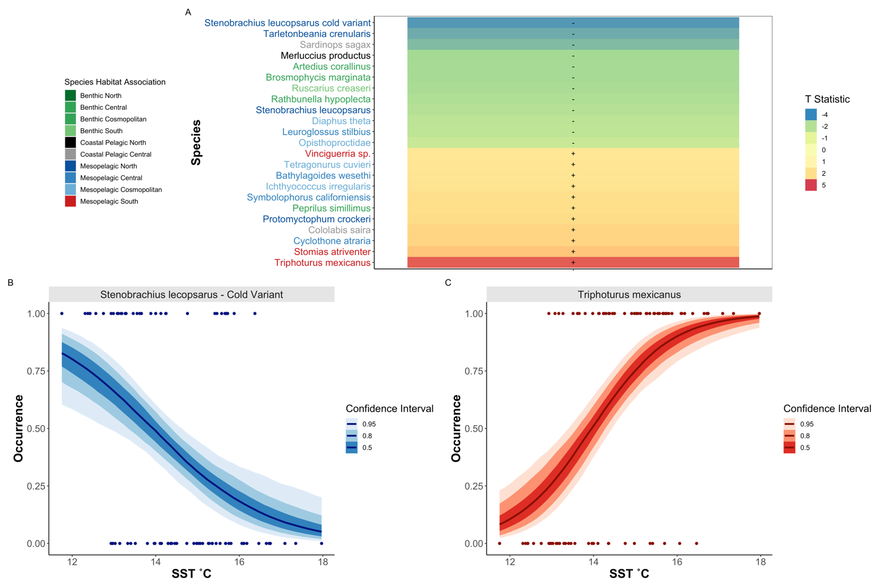

**Figure 1. Temperature-Occurrence Associations in Fish Species**

Changes in species occurrence patterns associated with SST, with southern, mesopelagic species increasing in prevalence with elevated temperature (A). T statistic (slope coefficient / standard error) from a generalized binomial mixed model was calculated for each species across all stations. Only 23 out of 56 total species with significant slopes (95% CI that exclude zero) are plotted. Importantly, metabarcoding identified cold-associated variants of the Northern Lanternfish (*Stennobrachius leucopsarus*) that cannot be morphologically identified (B) as well as common warm-associated species such as the Mexican Lampfish (*Triphoturus mexicanus*) (C).

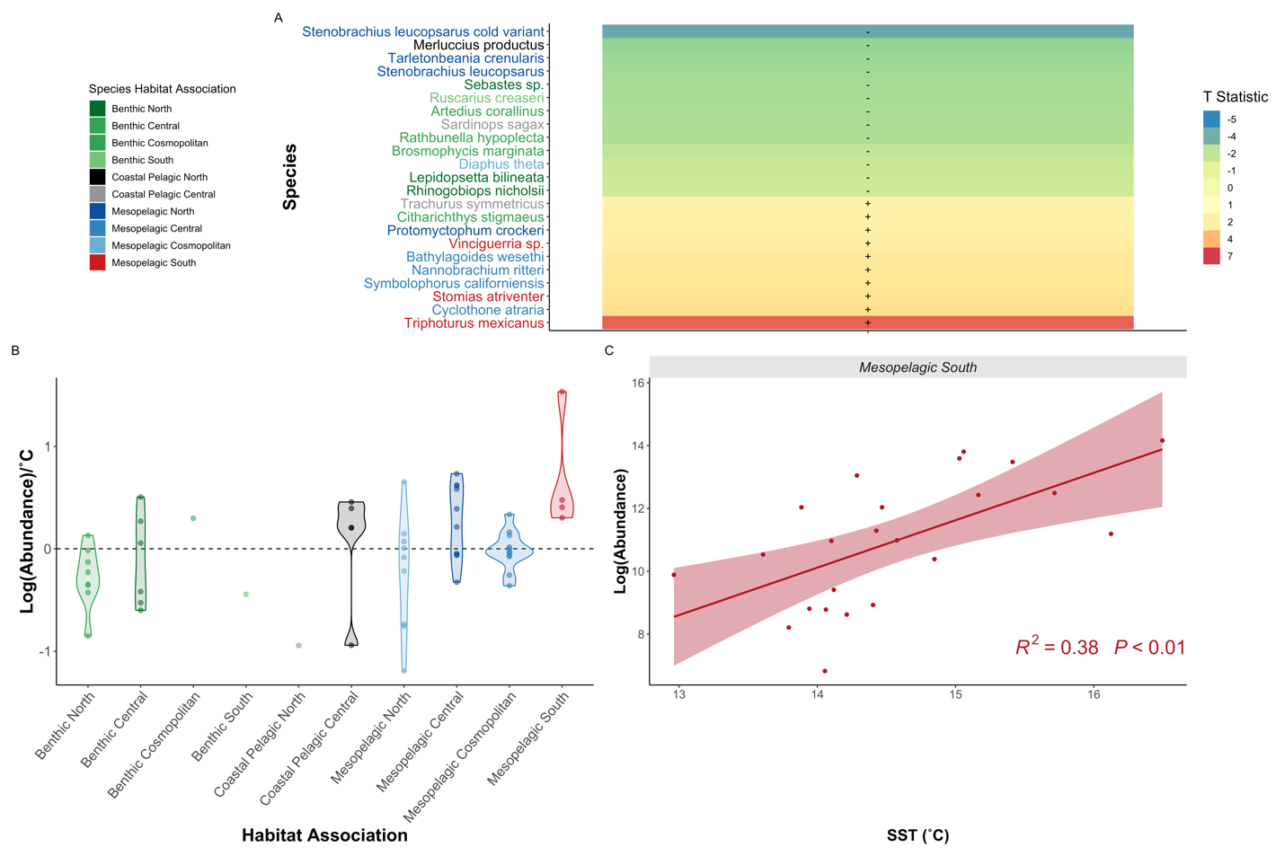

**Figure 2. Increased Abundance of Southern Oceanic Species Drive Fish Community Shifts**

Changes in species abundance in response to SST ˚C, with southern, mesopelagic species increasing in abundance with elevated sea surface temperature (A). As in Fig 1, significant T statistics from generalized linear models are plotted. Southern mesopelagic fishes were associated with increased temperature as indicated by summarizing species-specific slopes from generalized linear models (B) and by the aggregated abundance relationship (C; each point is the mean posterior estimate of abundance for all southern, mesopelagic species in a single year). In contrast, abundances of benthic species and coastal pelagic species such as Northern Hake and Pacific Sardine abundances, were associated with cooler temperatures.

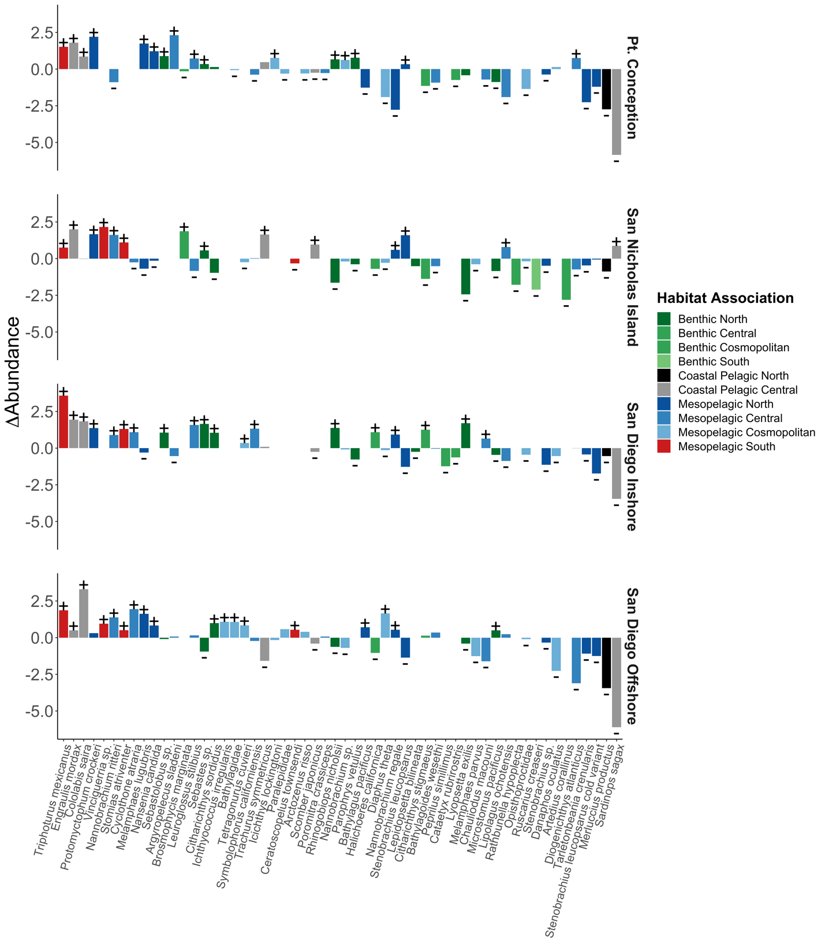

**Figure 3. Novel Marine Heatwave Assemblages**

Shifts in species abundances before the MHW (1996-2013) compared to during and after the MHW (2014-2019). Synchronous increases in southern, mesopelagics and Northern Anchovy were observed across all stations. Here, stations are shown in rows, species in columns, and the change in abundance between the two ecological phases shown as the response variable. Fisheries targets including Pacific Sardine and North Pacific Hake, as well as many other benthic and coastal species, had concurrent negative associations. Significant differences during and after the MHW are marked with + or -.

*Biomass Changes in Forage Fishes*

Both because of their own commercial value and because they are prey for other high-value fishery species, sardine and anchovy fluctuations have been a major focus of fisheries research since the 1950s (*9*). Our model estimates are consistent with other studies (*20*, *32*) that documented a decline in both sardines and anchovy beginning in 2005. This period of time was followed by high abundances of anchovy, but continued low abundances of sardine in the wake of the MHW, 2015-2019 (Figure 4). Although anchovy larvae abundance was low in spring during the 2014-2016 MHW, anchovy recruitment was high in summer 2015 (*33*). Anchovy mature in approximately one to two years (*32*, *34*) and thus the 2015 class likely began spawning in mid-2016 (*20*), leading to high anchovy spawning stock biomass and larval abundances by 2016 and lasting into 2019 and 2020 (*35*).

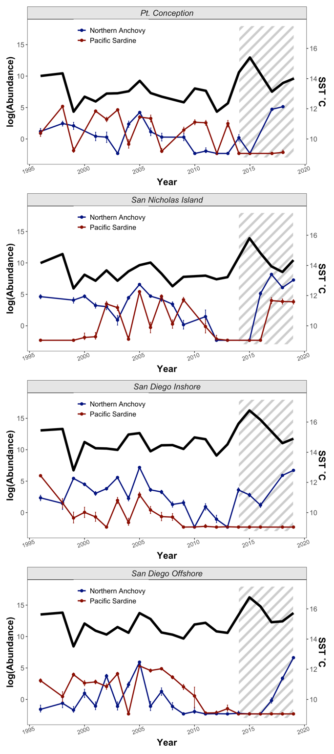

**Figure 4. Synchronous Increase in Anchovy Abundance During and After Marine Heatwave**

Posterior estimates for larval fish abundances (counts/10m2) over time at each of the four sampled stations. Joint modeling of metabarcoding and morphological counts reconstructed increases in Northern Anchovy (*Engraulis mordax*) [blue] during the recent Pacific Marine Heatwave and low spawning of Pacific Sardine (*Sardinops* sagax) [red] over the past decade (points are means and error bars are 95% credible intervals; shaded region is during and after the MHW). SST is plotted above the Northern Anchovy and Pacific Sardine abundances, for reference.

**Discussion**

*Displacement of Target Fish Species and Tropicalization of Fish Assemblages Associated with the Marine Heatwave*

Recent studies demonstrate the tropicalization of terrestrial and marine ecosystems in response to climate change (*40*, *41*). These shifts can induce novel species interactions, catalyzing changes in ecosystem function (*2*, *25*). For example, we observe the combination of high abundances of both Northern Anchovy and southern, mesopelagics (*5*, *38*) – a pattern otherwise undocumented in the previous >70-year CalCOFI dataset (*16*, *20*). Furthermore, our results suggest multiple coastal pelagic fisheries targets may continue to be scarce as environmental conditions that are similar to the 2014-2016 MHW become more common (*5*, *38*, *39*). Although the ecological implications of these novel assemblages are, by definition, unpredictable, our results suggest that if future assemblages resemble those seen in the MHW, increases in Northern Anchovy and southern, mesopelagic fishes are likely to be associated with decreases in Pacific Sardine and North Pacific Hake in the Southern CCLME (*40*, *41*); these shifts have fundamentally changed ecosystems and fisheries relative to the recent past (*20*).

*Biomass Changes in Forage Fishes*

The rise in anchovy and continued low abundances of sardine during the MHW is an ecological surprise. Correlative analyses between basin-scale environmental indices such as the Pacific Decadal Oscillation indicate that, for the latter half of the 20th century, anchovy thrived under cooler conditions and sardine under warmer conditions (*10*). However, our findings and others (*5*, *9*, *38*, *42*) suggest that the mechanisms that govern the population dynamics of these species are not a mere function of temperature, but that more complex factors drive recruitment dynamics of these species (*20*). For example, despite largely synchronous responses of fish assemblages to the marine heatwave, sardine declines were not consistent across the CCLME, with refugia of localized abundance in nearshore waters potentially driven by distinct, favorable conditions (*9*, *20*, *32*).

Further improving our mechanistic understanding of drivers of fish assemblage dynamics will better inform ecological predictions in the face of extreme ocean events such as MHWs which are likely to increase in frequency and duration under climate change (*43*). As we demonstrate, a combination of metabarcoding and visual surveys can characterize species across trophic levels (*44*) and this has the potential to reveal ecological mechanisms. Here, we used metabarcoding to accurately characterize the composition of larval fishes in CalCOFI plankton samples. Future efforts could focus on documenting the phytoplankton and zooplankton assemblages that comprise both larval prey and predators. Several major hypotheses seeking to explain recruitment variability are underpinned by the capacity of young larvae to consume appropriate prey that facilitates faster growth (*45*). Unfortunately, accurately characterizing the larval prey field has traditionally been difficult as prey are generally too small to be accurately sampled by nets (*46*). Metabarcoding of water samples from the same locations where larvae are collected, however, can characterize the larval prey field at an unprecedentedly high level of detail. In addition, metabarcoding of the stomachs of larval fishes can then identify actual prey items that were consumed by larvae. Evaluating the larval prey field and gut contents through metabarcoding will help us to finally understand the drivers of recruitment volatility in coastal pelagic and other fishes (*5*, *32*, *47*–*51*).

The described unexpected rise in anchovy during the 2014-16 MHW resonated throughout the CCLME (*39*). For example, California sea lion pups grew at anomalously high rates after their mothers consumed copious anchovy forage and produced ample milk (*40*). High rates of almost exclusively anchovy consumption also seemingly induced thiamine deficiency in adult salmon resulting in poor condition of recruits (*52*). Birds capable of feeding on anchovy thrived (*38*) while those unable to consume anchovy perished (*41*). Given that conditions comparable to the 2014–2016 MHW are predicted to be more common in the CCLME in the future (*1*), our results suggest that continued biological responses to both anchovy-dominated forage-fish assemblages and MHW-associated ocean warming conditions are likely to be without modern analog (*20*).

*Novel Insights from Legacy Collections*

Molecular tools differentiated variants and species that were not morphologically identifiable in the ichthyoplankton (*21*).For example, metabarcoding identified unique cold-associated variants of the Northern Lampfish (*Stennobrachius leucopsarus*) that are morphologically indistinguishable and combined as a complex are only weakly associated with cooler temperatures. By illuminating such unseen variation, molecular methods reveal ecological dynamics otherwise hidden by shared larval morphology.

Ultimately, our approach to studying historical fluctuations in ichthyoplankton assemblages reveals climate-associated biological changes in the CCLME, and suggests ways in which these changes could alter the function and socio-economic benefits derived from marine ecosystems. Importantly, this novel approach provides quantitative estimates by non-destructively sampling legacy collections via metabarcoding, and at the same time provides a mechanistic framework for determining absolute abundance estimates from compositional amplicon sequencing data (*53*–*56*). Here we relied on morphological counts to ground compositional metabarcoding data, but our framework suggests that any estimate of abundance (e.g. qPCR) or amplification efficiency (e.g. derived from mock communities) can achieve similar results (See Supplement 2) (*55*, *56*). Unlocking such quantitative metabarcoding approaches expands the potential for linking ecological assemblages to environmental processes beyond just presence-absence analyses (*57*–*59*). Such quantitative approaches may prove critical in modeling and predicting future ecosystem change, although directly linking assemblage dynamic responses to climate-driven forces remains inherently challenging. While the CalCOFI samples are specific to ichthyoplankton from the CCLME, bulk collection of community samples is commonly used to survey plankton, insects, pollen, gut contents, and microbiomes, among many other targets (*60*). As such, here we provide broadly applicable methodology with which to efficiently understand modern and historical changes in ecological communities.

**Materials and Methods**

*Study Design*

To investigate decadal changes in the ichthyoplankton assemblages in the California Current vicinity, we identified ichthyoplankton from four distinct stations during spring months. Archived spring ichthyoplankton samples were collected across four biogeographically dissimilar stations with variable water properties (*61*) over 2 decades (1996,1998-2019; Figure S1; See Supplement 1 methods)(*5*, *38*). Decades of research within the study region (*16*, *17*, *20*, *62*) indicate the majority of species spawn in spring and closely track adult biomass (*63*). Hence, we expect the spring ichthyoplankton to reflect underlying changes in the local fish assemblages.

At each station, oblique bongo net tows were conducted from 210 m depth to the surface using standard CalCOFI methods (*15*, *64*–*66*). Cod end contents of both bongo nets were preserved at sea. The starboard side was preserved in sodium borate-buffered 2% formaldehyde and the port side was preserved in Tris-buffered 95% ethanol. Microscopy was conducted to identify species abundance from formaldehyde-preserved samples following standardized CalCOFI techniques (*61*). DNA metabarcoding was conducted on the ethanol in which port side samples were preserved using the MiFish Universal Teleost (*67*) PCR primer set targeting the *12S* rRNA mitochondrial gene region. See Supplement 1 methods for full description.

*Estimating Abundance*

We estimated the abundance of ichthyoplankton in each jar using a novel joint Bayesian hierarchical model described in detail in Supplement 2. In brief, we estimate that the number of sequenced amplicons, for any species *i,* is proportional to the species-specific fraction of DNA in the PCR template (*53*, *55*, *56*). The amplicons produced during a PCR reaction are dictated by the amplicon efficiency parameter $a_{i}$, which is characteristic of the interaction between the particular primer set and each species being amplified. Thus, for any species *i*, the number of amplicons should be directly related to the efficiency of amplification and the starting concentration of DNA template such that

$A_{i}=c_{i}{{(a}_{i}+1)}^{N_{PCR}}$ (1)

where $A_{i}$ is amplicon abundance, $c_{i}$ is the true number of DNA copies in the reaction attributable to species *i*, $a_{i}$ is the species-specific amplification efficiency (bounded on (0,1)), and $N_{PCR}$ is the number of PCR cycles used in the reaction (*68*).

However, not all molecules of DNA are transferred through each molecular step (*69*, *70*), changing what in eq. 1 appears to be a single-species process – each species being amplified independently – into a multi-species process; the number of amplicons observed for species *i* will depend upon both the amplicons produced for species *i* = 1 and the amplicons produced for species *i* = 2, 3, ..., *I* in the same reaction. Observations of amplicons are thus compositional data, meaning they are the proportions of the sample amplicon reads and convey relative quantitative information of the observed species and therefore need to be analyzed as such (*54*).

To retain the data-generating structure from eq.1 as much as possible, we develop a model for a single sample with many species. As above, if we let *I* index species with *I* = 1, 2, ..., *I*, then we can write a deterministic equation for the number of amplicons observed in log-space as

${log⁡(A}_{i})=\log\left(c_{i}\right)+N_{PCR} log\left(a_{i}+1\right)+log(η)$ (2)

where the only new term is η, representing the proportion of reads observed from a given sampling run (See supplement 2 for details). Note that in this formulation η is a single value shared across all species and serves to scale the number of amplicons observed. Additionally, we can rewrite the number of DNA copies in terms of proportional number of counts, log($β_{i}$) = log($c_{i}$) − log($\sum_{i}{c_{i}}$) . Note that the second term in this equation is a sum of the counts across all species, and so is a single shared value for all species. As such it can be integrated into the value η that scales the overall abundance for each species *i*,

${log⁡(A}_{i})=\log\left(β_{i}\right)+N_{PCR} log\left(a_{i}+1\right)+log(η)$ (3)

This equation is appealing because it provides a process-oriented description of the biology of interest (the βs), a term for how PCR modifies our amplicon sequence count observation of the true abundance ( $N_{PCR} log\left(a_{i}+1\right))$, and a term for how subsampling of DNA reads will adjust the number of amplicons observed (log(η)).

However, in the absence of additional information, it is not possible to estimate the β and *a* parameters from metabarcoding data alone. Including morphological count data enables us to estimate the confounded parameters from metabarcoding data. For each sampled station, we have two independent sets of observed data: 1) counts of larval/juvenile fishes for each taxon from the formaldehyde jars and 2) counts of amplicons for each taxon from ethanol jars. These observed data arise from a common (but unobserved) biomass for each species at each station-year combination, and thus we can model them jointly (*71*).

Microscopy counts were modeled as Poisson-distributed given their relatively small absolute values and low variance (*64*), and amplicon sequence data were modeled using a Negative Binomial distribution given their relatively high absolute values and high variability among replicates (Figure S2-S4). These statistical distributions are commonly used in models of amplicon and count data, respectively (*35*–*37*). A full description of model implementation and assumptions are provided in Supplement 2.

*Data Analysis*

After model estimation, we calculated mean abundance estimates (larvae counts per standardized volume towed) per species per station per year. To explore species-specific sea surface temperature (SST) relationships, we fit a Bayesian generalized linear model using log (abundance) as the response variable and SST (˚C) as a continuous predictor variable. Models were implemented for each species using Stan as implemented in R (*75*, *76*). We then summarized the affinity between each species and SST by calculating a T-statistic based on each species' estimated coefficients (mean slope/standard deviation). We further plotted the estimated slope for each “species grouping” by habitat associations derived from previous CalCOFI research (See Supplement 1 methods)(*63*). We summed total log (abundance) per habitat association per station per year and fit a Bayesian generalized linear model using log (total abundance) as the response variable and SST (˚C) as a continuous predictor variable.

We repeated the above analyses using a Bayesian binomial model using presence as the response variable and SST (˚C) as a continuous predictor variable across the data set to explore occurrence relationships with temperature and identify warm- and cool- associated taxa. We set a threshold of presence/absence based on the model using a threshold of < 0.01 larvae per standardized volume to be considered absent within a station.

We further explored species occurrence and abundance relationships with SST by fitting the above Bayesian generalized linear models with station as a random effect (See Supplement 1 results).

We visualized anchovy and sardine abundance over time by calculating the mean log (abundance) of each species per station per year. We then plotted the mean log (abundance) of each of the four stations while error bars represent the 95% confidence intervals observed for a given species at a given station in that year.

To evaluate the effect of the marine heatwave (MHW) on CCLME fishes we compared estimated species abundances before the MHW (1996-2013), to both during and after the MHW (2014-2019), at each station respectively. We first calculated the mean abundance for each species at each station for each model run. We then subtracted the means for each model run to evaluate changes in MHW abundance per species per station per model run. We then calculated a 95% CI of change in MHW abundance per species to identify which species were significantly different before vs. during and after the MHW at each station.

All data and code to conduct analyses and generate all figures are available on GitHub (https://github.com/zjgold/CalCOFI_eDNA) and associated Google Drive link (https://drive.google.com/drive/folders/12cU9mY_CWoro-x6Hgh_pgv_66zZEzm1h?usp=sharing) [will be replaced with a Dryad repository upon acceptance].

**Acknowledgments**

*Funding*

We acknowledge NSF GRFP and GRIP [DEG No. 2015204395], UCLA La Kretz Center for Conservation Genomics, Howard Hughes Medical Institute, and UCLA Department of Ecology and Evolutionary Biology for funding this research.

*Author Contributions*

* Conceptualization: ZG, DK, KDG, ART, LRT, PHB
* Performed Research: ZG, RPK, AOS, RG, DK, ART, PHB, KMP
* Funding Acquisition: ZG, PHB, ART, KDG, DK
* Data Curation: ZG, RPK, AOS, RG
* Formal Analysis: ZG, RPK, AOS, RG, ART
* Writing – Original Draft Preparation: ZG, RPK, AOS, ART, KDG, RG, KMP, LRT, DK, PHB

*Competing Interests*

The authors declare no competing interests.

*Data and Materials Availability*

All data needed to evaluate the conclusions in the paper are present in the paper and/or the Supplementary Materials.

**References**

1. E. C. J. Oliver, S. E. Perkins-Kirkpatrick, N. J. Holbrook, N. L. Bindoff, 9. Anthropogenic and natural influences on record 2016 marine heat waves. *Bull. Am. Meteorol. Soc.* **99**, S44–S48 (2018).

2. T. L. Frölicher, C. Laufkötter, Emerging risks from marine heat waves. *Nat. Commun.* **9** (2018), pp. 1–4.

3. T. P. Hughes, J. T. Kerry, A. H. Baird, S. R. Connolly, A. Dietzel, C. M. Eakin, S. F. Heron, A. S. Hoey, M. O. Hoogenboom, G. Liu, M. J. McWilliam, R. J. Pears, M. S. Pratchett, W. J. Skirving, J. S. Stella, G. Torda, Global warming transforms coral reef assemblages. *Nature*. **556**, 492–496 (2018).

4. L. Rogers-Bennett, C. A. Catton, Marine heat wave and multiple stressors tip bull kelp forest to sea urchin barrens. *Sci. Rep.* **9**, 1–9 (2019).

5. J. M. Nielsen, L. A. Rogers, R. D. Brodeur, A. R. Thompson, T. D. Auth, A. L. Deary, J. T. Duffy-Anderson, M. Galbraith, J. A. Koslow, R. I. Perry, Responses of ichthyoplankton assemblages to the recent marine heatwave and previous climate fluctuations in several Northeast Pacific marine ecosystems. *Glob. Chang. Biol.* **27**, 506–520 (2021).

6. W. W. L. Cheung, T. L. Frölicher, Marine heatwaves exacerbate climate change impacts for fisheries in the northeast Pacific. *Sci. Rep.* **10**, 1–10 (2020).

7. M. L. Pinsky, R. L. Selden, Z. J. Kitchel, Climate-Driven Shifts in Marine Species Ranges: Scaling from Organisms to Communities. *Ann. Rev. Mar. Sci.* **12**, 153–179 (2020).

8. E. A. Becker, K. A. Forney, J. V. Redfern, J. Barlow, M. G. Jacox, J. J. Roberts, D. M. Palacios, Predicting cetacean abundance and distribution in a changing climate. *Divers. Distrib.* **25**, 626–643 (2019).

9. D. M. Checkley, R. G. Asch, R. R. Rykaczewski, Climate, Anchovy, and Sardine. *Ann. Rev. Mar. Sci.* **9**, 469–493 (2017).

10. F. P. Chavez, J. Ryan, S. E. Lluch-Cota, C. M. Ñiquen, Climate: From anchovies to sardines and back: Multidecadal change in the Pacific Ocean. *Science (80-. ).* **299**, 217–221 (2003).

11. M. Lindegren, D. M. Checkley, T. Rouyer, A. D. MacCall, N. C. Stenseth, Climate, fishing, and fluctuations of sardine and anchovy in the California Current. *Proc. Natl. Acad. Sci. U. S. A.* **110**, 13672–13677 (2013).

12. N. D. , E. Drenkard, A. R. Thompson, E. D. Weber, D. Wilson-Vandenberg, S. McClatchie, J. A. Koslow, B. X. Semmens, Bridging From Monitoring to Solutions-Based Thinking: Lessons From CalCOFI for Understanding and Adapting to Marine Climate Change Impacts. *Front. Mar. Sci.* **6**, 695 (2019).

13. P. E. Smith, H. G. Moser, Long-term trends and variability in the larvae of Pacific sardine and associated fish species of the California Current region. *Deep. Res. Part II Top. Stud. Oceanogr.* **50**, 2519–2536 (2003).

14. C. H. Hsieh, C. S. Reiss, J. R. Hunter, J. R. Beddington, R. M. May, G. Sugihara, Fishing elevates variability in the abundance of exploited species. *Nature*. **443**, 859–862 (2006).

15. A. R. Thompson, W. Watson, S. McClatchie, E. D. Weber, Multi-scale sampling to evaluate assemblage dynamics in an oceanic marine reserve. *PLoS One*. **7**, e33131 (2012).

16. H. G. Moser P.E. Smith, and L.E. Eber, Larval fish assemblages in the California Current region, 1954-1960, a period of dynamic environmental change. *CalCOFI Rep.* **28**, 97–127 (1987).

17. H. Moser, R. Charter, P. Smith, D. Ambrose, W. Watson, S. Charter, E. Sandknop, Distributional atlas of fish larvae and eggs in the Southern California Bight region: 1951-1998. *Calif. Coop. Ocean. Fish. Investig. Atlas*. **34**, 1–166 (2001).

18. M. A. Snyder, L. C. Sloan, N. S. Diffenbaugh, J. L. Bell, Future climate change and upwelling in the California Current. *Geophys. Res. Lett.* **30**, 1823 (2003).

19. R. G. Asch, Climate change and decadal shifts in the phenology of larval fishes in the California Current ecosystem. *Proc. Natl. Acad. Sci. U. S. A.* **112**, E4065–E4074 (2015).

20. A. R. Thompson, N. J. Ben-Aderet, N. M. Bowlin, D. Kacev, R. Swalethorp, W. Watson, Putting the Pacific marine heatwave into perspective: The response of larval fish off southern California to unprecedented warming in 2014–2016 relative to the previous 65 years. *Glob. Chang. Biol.* **28**, 1766–1785 (2022).

21. A. R. Thompson, D. C. Chen, L. W. Guo, J. R. Hyde, W. Watson, Larval abundances of rockfishes that were historically targeted by fishing increased over 16 years in association with a large marine protected area. *R. Soc. Open Sci.* **4**, 170639 (2017).

22. Z. Gold, E. E. Curd, K. D. Goodwin, E. S. Choi, B. W. Frable, A. R. Thompson, H. J. Walker, R. S. Burton, D. Kacev, L. D. Martz, P. H. Barber, Improving metabarcoding taxonomic assignment: A case study of fishes in a large marine ecosystem. *Mol. Ecol. Resour.* **21**, 2546–2564 (2021).

23. M. Miya, R. O. Gotoh, T. Sado, MiFish metabarcoding: a high-throughput approach for simultaneous detection of multiple fish species from environmental DNA and other samples. *Fish. Sci.* **86**, 939–970 (2020).

24. M. G. Jacox, M. A. Alexander, N. J. Mantua, J. D. Scott, G. Hervieux, R. S. Webb, F. E. Werner, 6. Forcing of multiyear extreme ocean temperatures that impacted California current living marine resources in 2016. *Bull. Am. Meteorol. Soc.* **99**, S27–S33 (2018).

25. C. A. Morgan, B. R. Beckman, L. A. Weitkamp, K. L. Fresh, Recent Ecosystem Disturbance in the Northern California Current. *Fisheries*. **44**, 465–474 (2019).

26. C. L. Gentemann, M. R. Fewings, M. García-Reyes, Satellite sea surface temperatures along the West Coast of the United States during the 2014–2016 northeast Pacific marine heat wave. *Geophys. Res. Lett.* **44**, 312–319 (2017).

27. A. S. Ren, D. L. Rudnick, Temperature and salinity extremes from 2014-2019 in the California Current System and its source waters. *Commun. Earth Environ.* **2**, 1–9 (2021).

28. I. D. Schroeder, J. A. Santora, S. J. Bograd, E. L. Hazen, K. M. Sakuma, A. M. Moore, C. A. Edwards, B. K. Wells, J. C. Field, Source water variability as a driver of rockfish recruitment in the California Current Ecosystem: implications for climate change and fisheries management. *Can. J. Fish. Aquat. Sci.* **76**, 950–960 (2019).

29. M. Miya, Y. Sato, T. Fukunaga, T. Sado, J. Y. Poulsen, K. Sato, T. Minamoto, S. Yamamoto, H. Yamanaka, H. Araki, M. Kondoh, W. Iwasaki, MiFish, a set of universal PCR primers for metabarcoding environmental DNA from fishes: Detection of more than 230 subtropical marine species. *R. Soc. Open Sci.* **2**, 150088 (2015).

30. E. E. Curd, Z. Gold, G. S. Kandlikar, J. Gomer, M. Ogden, T. O’Connell, L. Pipes, T. M. Schweizer, L. Rabichow, M. Lin, B. Shi, P. H. Barber, N. Kraft, R. Wayne, R. S. Meyer, Anacapa Toolkit: An environmental DNA toolkit for processing multilocus metabarcode datasets. *Methods Ecol. Evol.* **10**, 1469–1475 (2019).

31. R. Gallego, E. Jacobs-Palmer, K. Cribari, R. P. Kelly, Environmental DNA metabarcoding reveals winners and losers of global change in coastal waters: EDNA and climate change. *Proc. R. Soc. B Biol. Sci.* **287**, 20202424 (2020).

32. W. J. Sydeman, S. Dedman, M. García-Reyes, S. A. Thompson, J. A. Thayer, A. Bakun, A. D. MacCall, Sixty-five years of northern anchovy population studies in the southern California Current: A review and suggestion for sensible management. *ICES J. Mar. Sci.* **77**, 486–499 (2020).

33. A. R. Thompson, I. D. Schroeder, S. J. Bograd, E. L. Hazen, M. G. Jacox, A. Leising, B. K. Wells, J. L. Largier, J. L. Fisher, K. C. Jacobson, S. M. Zeman, E. P. Bjorktedt, R. R. Robertson, M. Kahru, R. Goericke, C. E. Peabody, T. Baumgartner, B. E. Lavaniegos, L. E. Miranda, E. Gómez-Ocampo, J. Gómez-Valdés, T. D. Authy, E. A. Daly, C. A. Morgan, J. B. Burke, J. C. Field, K. Sakuma, E. D. Weber, W. Watson, J. M. Porquez, J. Dolliver, D. E. Lyons, R. A. Orben, J. Zamon, P. Warybok, J. Jahncke, J. A. Santora, S. A. Thompson, B. Hoover, W. J. Sydeman, S. Melin, State of the California current 2018-19 : a novel anchovy regime and a new marine heat wave? *Calif. Coop. Ocean. Fish. Investig. Rep.* **60**, 1–60 (2019).

34. R. H. Parrish, D. L. Mallicoate, R. A. Klingbeil, Age dependent fecundity, number of spawninge per year, sex ratio, and maturation stages in northern anchovy, Engraulis mordax. *Fish. Bull.* **84**, 503–517 (1986).

35. E. D. Weber, T. D. Auth, S. Baumann-Pickering, T. R. Baumgartner, E. P. Bjorkstedt, S. J. Bograd, B. J. Burke, J. L. Cadena-Ramírez, E. A. Daly, M. de la Cruz, State of the California Current 2019–2020: Back to the Future With Marine Heatwaves? *Front. Mar. Sci.*, 1081 (2021).

36. A. Vergés, C. Doropoulos, H. A. Malcolm, M. Skye, M. Garcia-Pizá, E. M. Marzinelli, A. H. Campbell, E. Ballesteros, A. S. Hoey, A. Vila-Concejo, Y. M. Bozec, P. D. Steinberg, Long-term empirical evidence of ocean warming leading to tropicalization of fish communities, increased herbivory, and loss of kelp. *Proc. Natl. Acad. Sci. U. S. A.* **113**, 13791–13796 (2016).

37. C. Chaudhary, A. J. Richardson, D. S. Schoeman, M. J. Costello, Global warming is causing a more pronounced dip in marine species richness around the equator. *Proc. Natl. Acad. Sci. U. S. A.* **118** (2021), doi:10.1073/pnas.2015094118.

38. A. R. Thompson, C. J. Harvey, W. J. Sydeman, C. Barceló, S. J. Bograd, R. D. Brodeur, J. Fiechter, J. C. Field, N. Garfield, T. P. Good, E. L. Hazen, M. E. Hunsicker, K. Jacobson, M. G. Jacox, A. Leising, J. Lindsay, S. R. Melin, J. A. Santora, I. D. Schroeder, J. A. Thayer, B. K. Wells, G. D. Williams, Indicators of pelagic forage community shifts in the California Current Large Marine Ecosystem, 1998–2016. *Ecol. Indic.* **105**, 215–228 (2019).

39. J. A. Santora, N. J. Mantua, I. D. Schroeder, J. C. Field, E. L. Hazen, S. J. Bograd, W. J. Sydeman, B. K. Wells, J. Calambokidis, L. Saez, D. Lawson, K. A. Forney, Habitat compression and ecosystem shifts as potential links between marine heatwave and record whale entanglements. *Nat. Commun.* **11**, 1–12 (2020).

40. H. Robinson, J. Thayer, W. J. Sydeman, M. Weise, Changes in California sea lion diet during a period of substantial climate variability. *Mar. Biol.* **165**, 1–12 (2018).

41. J. F. Piatt, J. K. Parrish, H. M. Renner, S. K. Schoen, T. T. Jones, M. L. Arimitsu, K. J. Kuletz, B. Bodenstein, M. García-Reyes, R. S. Duerr, R. M. Corcoran, R. S. A. Kaler, G. J. McChesney, R. T. Golightly, H. A. Coletti, R. M. Suryan, H. K. Burgess, J. Lindsey, K. Lindquist, P. M. Warzybok, J. Jahncke, J. Roletto, W. J. Sydeman, Extreme mortality and reproductive failure of common murres resulting from the northeast Pacific marine heatwave of 2014-2016. *PLoS One*. **15**, e0226087 (2020).

42. S. McClatchie, Sardine biomass is poorly correlated with the Pacific Decadal Oscillation off California. *Geophys. Res. Lett.* **39** (2012), doi:10.1029/2012GL052140.

43. C. Deutsch, A. Ferrel, B. Seibel, H. O. Pörtner, R. B. Huey, Climate change tightens a metabolic constraint on marine habitats. *Science (80-. ).* **348**, 1132–1135 (2015).

44. K. A. Rose, J. Fiechter, E. N. Curchitser, K. Hedstrom, M. Bernal, S. Creekmore, A. Haynie, S. ichi Ito, S. Lluch-Cota, B. A. Megrey, C. A. Edwards, D. Checkley, T. Koslow, S. McClatchie, F. Werner, A. MacCall, V. Agostini, Demonstration of a fully-coupled end-to-end model for small pelagic fish using sardine and anchovy in the California Current. *Prog. Oceanogr.* **138**, 348–380 (2015).

45. J. A. Hare, The future of fisheries oceanography lies in the pursuit of multiple hypotheses. *ICES J. Mar. Sci.* **71**, 2343–2356 (2014).

46. D. Robert, H. M. Murphy, G. P. Jenkins, L. Fortier, Poor taxonomical knowledge of larval fish prey preference is impeding our ability to assess the existence of a “critical period” driving year-class strength. *ICES J. Mar. Sci.* **71**, 2042–2052 (2014).

47. E. Garcia-Vazquez, O. Georges, S. Fernandez, A. Ardura, eDNA metabarcoding of small plankton samples to detect fish larvae and their preys from Atlantic and Pacific waters. *Sci. Rep.* **11**, 1–13 (2021).

48. K. J. Pitz, J. Guo, S. B. Johnson, T. L. Campbell, H. Zhang, R. C. Vrijenhoek, F. P. Chavez, J. Geller, Zooplankton biogeographic boundaries in the California Current System as determined from metabarcoding. *PLoS One*. **15**, e0235159 (2020).

49. C. Mariac, J. F. Renno, G. Carmen, Y. Vigouroux, E. Mejia, C. Angulo, D. Castro Ruiz, G. Estivals, C. Nolorbe, A. García Vasquez, J. Nuñez, G. Cochonneau, M. Flores, J. Alvarado, J. Vertiz, W. Chota-Macuyama, H. Sánchez, G. Miranda, F. Duponchelle, Species-level ichthyoplankton dynamics for 97 fishes in two major river basins of the Amazon using quantitative metabarcoding. *Mol. Ecol.* (2021), doi:10.1111/mec.15944.

50. M. Barbato, T. Kovacs, M. A. Coleman, M. K. Broadhurst, M. de Bruyn, Metabarcoding for stomach-content analyses of Pygmy devil ray (Mobula kuhlii cf. eregoodootenkee): Comparing tissue and ethanol preservative-derived DNA. *Ecol. Evol.* **9**, 2678–2687 (2019).

51. M. Erdozain, D. G. Thompson, T. M. Porter, K. A. Kidd, D. P. Kreutzweiser, P. K. Sibley, T. Swystun, D. Chartrand, M. Hajibabaei, Metabarcoding of storage ethanol vs. conventional morphometric identification in relation to the use of stream macroinvertebrates as ecological indicators in forest management. *Ecol. Indic.* **101**, 173–184 (2019).

52. H. L. Thalmann, E. A. Daly, R. D. Brodeur, Two Anomalously Warm Years in the Northern California Current: Impacts on Early Marine Steelhead Diet Composition, Morphology, and Potential Survival. *Trans. Am. Fish. Soc.* **149**, 369–382 (2020).

53. R. P. Kelly, A. O. Shelton, R. Gallego, Understanding PCR Processes to Draw Meaningful Conclusions from Environmental DNA Studies. *Sci. Rep.* **9**, 1–14 (2019).

54. G. B. Gloor, J. M. Macklaim, V. Pawlowsky-Glahn, J. J. Egozcue, Microbiome datasets are compositional: And this is not optional. *Front. Microbiol.* **8**, 2224 (2017).

55. M. R. McLaren, A. D. Willis, B. J. Callahan, Consistent and correctable bias in metagenomic sequencing experiments. *Elife*. **8**, e46923 (2019).

56. J. D. Silverman, R. J. Bloom, S. Jiang, H. K. Durand, E. Dallow, S. Mukherjee, L. A. David, Measuring and mitigating PCR bias in microbiota datasets. *PLoS Comput. Biol.* **17**, e1009113 (2021).

57. M. Y. Stoeckle, J. Adolf, Z. Charlop-Powers, K. J. Dunton, G. Hinks, S. M. Vanmorter, Trawl and eDNA assessment of marine fish diversity, seasonality, and relative abundance in coastal New Jersey, USA. *ICES J. Mar. Sci.* **78**, 293–304 (2021).

58. A. Lacoursière-Roussel, G. Côté, V. Leclerc, L. Bernatchez, Quantifying relative fish abundance with eDNA: a promising tool for fisheries management. *J. Appl. Ecol.* **53**, 1148–1157 (2016).

59. M. C. Yates, D. J. Fraser, A. M. Derry, Meta-analysis supports further refinement of eDNA for monitoring aquatic species-specific abundance in nature. *Environ. DNA*. **1**, 5–13 (2019).

60. M. M. Zenker, A. Specht, V. G. Fonseca, Assessing insect biodiversity with automatic light traps in Brazil: Pearls and pitfalls of metabarcoding samples in preservative ethanol. *Ecol. Evol.* **10**, 2352–2366 (2020).

61. S. McClatchie, A. R. Thompson, S. R. Alin, S. Siedlecki, W. Watson, S. J. Bograd, The influence of Pacific Equatorial Water on fish diversity in the southern California Current System. *J. Geophys. Res. Ocean.* **121**, 6121–6136 (2016).

62. H. G. Moser, R. L. Charter, P. E. Smith, D. A. Ambrose, S. R. Charter, C. A. Meyer, E. M. Sandknop, W. Watson, *Distributional atlas of fish larvae and eggs in the California Current region: taxa with 1000 or more total larvae, 1951 through 1984* (Marine Life Research Program, Scripps Institution of Oceanography, 1993), vol. 53.

63. C. H. Hsieh, C. Reiss, W. Watson, M. J. Allen, J. R. Hunter, R. N. Lea, R. H. Rosenblatt, P. E. Smith, G. Sugihara, A comparison of long-term trends and variability in populations of larvae of exploited and unexploited fishes in the Southern California region: A community approach. *Prog. Oceanogr.* **67**, 160–185 (2005).

64. A. R. Thompson, S. McClatchie, E. D. Weber, W. Watson, C. E. Lennert-Cody, Correcting for bias in calcofi ichthyoplankton abundance estimates associated with the 1977 transition from ring to bongo net sampling. *Calif. Coop. Ocean. Fish. Investig. Reports*. **58**, 1–11 (2017).

65. D. Kramer, M. J. Kalin, E. G. Stevens, J. R. Thrailkill, J. . Zweifel, *Collecting and processing data on fish eggs and larvae in the California Current. NOAA Tech. Rep. NMFS Circ., vol. 370.* (US Department of Commerce, National Oceanic and Atmospheric Administration …, 1972), vol. 370.

66. S. McClatchie, *Regional fisheries oceanography of the california current system: The CalCOFI program* (Springer, 2014).

67. M. Miya, Y. Sato, T. Fukunaga, T. Sado, J. Y. Poulsen, K. Sato, T. Minamoto, S. Yamamoto, H. Yamanaka, H. Araki, M. Kondoh, W. Iwasaki, MiFish, a set of universal PCR primers for metabarcoding environmental DNA from fishes: Detection of more than 230 subtropical marine species. *R. Soc. Open Sci.* **2**, 150088 (2015).

68. N. Lalam, Estimation of the reaction efficiency in polymerase chain reaction. *J. Theor. Biol.* **242**, 947–953 (2006).

69. J. D. Silverman, K. Roche, S. Mukherjee, L. A. David, Naught all zeros in sequence count data are the same. *Comput. Struct. Biotechnol. J.* **18**, 2789–2798 (2020).

70. J. J. Jos´, J. Egozcue, J. Graffelman, M. I. Ortego, V. Pawlowsky-Glahn, Some thoughts on counts in sequencing studies. *NAR Genomics Bioinforma.* **2**, 1–10 (2020).

71. N. T. Hobbs, M. B. Hooten, *Bayesian Models: A Statistical Primer for Ecologists. 593 Princeton University Press* (Princeton, 2015).

72. X. Ren, P. F. Kuan, Negative binomial additive model for RNA-Seq data analysis. *BMC Bioinformatics*. **21**, 1–15 (2020).

73. T. Chambert, D. S. Pilliod, C. S. Goldberg, H. Doi, T. Takahara, An analytical framework for estimating aquatic species density from environmental DNA. *Ecol. Evol.* **8**, 3468–3477 (2018).

74. E. Meyer-Gutbrod, L. Kui, R. Miller, M. Nishimoto, L. Snook, M. Love, Moving on up: Vertical distribution shifts in rocky reef fish species during climate-driven decline in dissolved oxygen from 1995 to 2009. *Glob. Chang. Biol.* **27**, 6280–6293 (2021).

75. B. Goodrich, J. Gabry, I. Ali, S. Brilleman, rstanarm: Bayesian applied regression modeling via Stan. *R Packag. version*. **2**, 1758 (2020).

76. Stan Development Team, RStan: the R interface to Stan (2021).

77. J. N. Heine, California Cooperative Oceanic Fisheries Investigations. Reports. **49**, 264 (2008).

78. S. McClatchie, J. Gao, E. J. Drenkard, A. R. Thompson, W. Watson, L. Ciannelli, S. J. Bograd, J. T. Thorson, Interannual and Secular Variability of Larvae of Mesopelagic and Forage Fishes in the Southern California Current System. *J. Geophys. Res. Ocean.* **123**, 6277–6295 (2018).

79. E. Valsecchi, J. Bylemans, S. J. Goodman, R. Lombardi, I. Carr, L. Castellano, A. Galimberti, P. Galli, Novel universal primers for metabarcoding environmental DNA surveys of marine mammals and other marine vertebrates. *Environ. DNA*. **2**, 460–476 (2020).

80. R. A. Collins, G. Trauzzi, K. M. Maltby, T. I. Gibson, F. C. Ratcliffe, J. Hallam, S. Rainbird, J. Maclaine, P. A. Henderson, D. W. Sims, S. Mariani, M. J. Genner, Meta-Fish-Lib: A generalised, dynamic DNA reference library pipeline for metabarcoding of fishes. *J. Fish Biol.* **99**, 1446–1454 (2021).

81. A. Polanco F., E. Richards, B. Flück, A. Valentini, F. Altermatt, S. Brosse, J. C. Walser, D. Eme, V. Marques, S. Manel, C. Albouy, T. Dejean, L. Pellissier, Comparing the performance of 12S mitochondrial primers for fish environmental DNA across ecosystems. *Environ. DNA*. **3**, 1113–1127 (2021).

82. K. Deiner, H. M. Bik, E. Mächler, M. Seymour, A. Lacoursière-Roussel, F. Altermatt, S. Creer, I. Bista, D. M. Lodge, N. de Vere, M. E. Pfrender, L. Bernatchez, Environmental DNA metabarcoding: Transforming how we survey animal and plant communities. *Mol. Ecol.* **26**, 5872–5895 (2017).

83. P. Taberlet, A. Bonin, L. Zinger, E. Coissac, *Environmental DNA: For biodiversity research and monitoring* (Oxford University Press, 2018).

84. R. C. Edgar, Accuracy of taxonomy prediction for 16S rRNA and fungal ITS sequences. *PeerJ*. **2018**, e4652 (2018).

85. M. A. Min, P. H. Barber, Z. Gold, MiSebastes: An eDNA metabarcoding primer set for rockfishes (genus Sebastes). *Conserv. Genet. Resour.* **13**, 447–456 (2021).

86. M. Leray, J. Y. Yang, C. P. Meyer, S. C. Mills, N. Agudelo, V. Ranwez, J. T. Boehm, R. J. Machida, A new versatile primer set targeting a short fragment of the mitochondrial COI region for metabarcoding metazoan diversity: Application for characterizing coral reef fish gut contents. *Front. Zool.* **10**, 34 (2013).

87. P. A. Hastings, R. S. Burton, Establishing a DNA Sequence database for the marine fish fauna of California, 5 (2008).

88. B. E. Deagle, S. N. Jarman, E. Coissac, F. Pompanon, P. Taberlet, DNA metabarcoding and the cytochrome c oxidase subunit I marker: Not a perfect match. *Biol. Lett.* **10**, 20140562 (2014).

89. J. L. O’donnell, R. P. Kelly, N. C. Lowell, J. A. Port, Indexed PCR primers induce template- Specific bias in Large-Scale DNA sequencing studies. *PLoS One*. **11**, e0148698 (2016).

90. D. M. Gohl, P. Vangay, J. Garbe, A. MacLean, A. Hauge, A. Becker, T. J. Gould, J. B. Clayton, T. J. Johnson, R. Hunter, D. Knights, K. B. Beckman, Systematic improvement of amplicon marker gene methods for increased accuracy in microbiome studies. *Nat. Biotechnol.* **34**, 942–949 (2016).

91. K. Bohmann, V. Elbrecht, C. Carøe, I. Bista, F. Leese, M. Bunce, D. W. Yu, M. Seymour, A. J. Dumbrell, S. Creer, Strategies for sample labelling and library preparation in DNA metabarcoding studies. *Mol. Ecol. Resour.* (2021), doi:10.1111/1755-0998.13512.

92. R. P. Kelly, R. Gallego, E. Jacobs-Palme, The effect of tides on nearshore environmental DNA. *PeerJ*. **2018**, e4521 (2018).

93. R. Mendelssohn, rerddapXtracto: Extracts Environmental Data from “ERDDAP” Web Services. R package version 1.0.0 (2020).

94. H. G. Moser, R. L. Charter, W. Watson, D. A. Ambrose, K. T. Hill, P. E. Smith, J. L. Butler, E. M. Sandknop, S. R. Charter, The CalCOFI ichthyoplankton time series: Potential contributions to the management of rocky-shore fishes. *Calif. Coop. Ocean. Fish. Investig. Reports*. **42**, 112–128 (2001).

95. S. Juggins, rioja: Analysis of Quaternary science data, R package version (0.9-9). *Compr. r Arch. Netw.* (2015).

96. A. de Vries, B. D. Ripley, Create Dendrograms and Tree Diagrams Using “ggplot2.” *URL https//github. com/andrie/ggdendro*, 12 (2020).

97. J. Oksanen, F. G. Blanchet, R. Kindt, P. Legendre, P. R. Minchin, O. R.B., G. L. Simpson, P. Solymos, M. H. H. Stevens, H. Wagner, *vegan*: Community ecology package. *R Packag. version 2.3-5* (2016), (available at https://cran.r-project.org/package=vegan).

98. J. Niku, F. K. C. Hui, S. Taskinen, D. I. Warton, gllvm: Fast analysis of multivariate abundance data with generalized linear latent variable models in r. *Methods Ecol. Evol.* **10**, 2173–2182 (2019).

99. A. Kucukelbir, R. Ranganath, A. Gelman, D. Blei, Automatic variational inference in Stan. *Adv. Neural Inf. Process. Syst.* **28** (2015).

100. R. Jiang, W. V. Li, J. J. Li, mbImpute: an accurate and robust imputation method for microbiome data. *Genome Biol.* **22**, 1–27 (2021).

101. M. Leray, N. Knowlton, Random sampling causes the low reproducibility of rare eukaryotic OTUs in Illumina COI metabarcoding. *PeerJ*. **2017**, e3006 (2017).

102. J. A. Royle, W. A. Link, Generalized site occupancy models allowing for false positive and false negative errors. *Ecology*. **87**, 835–841 (2006).

**SUPPLEMENT 1**

**Table of Contents**

1. **Methods**
   1. *Study Design*
   2. *Metabarcoding Collection Isolation, Amplification, and Sequencing*
   3. *Bioinformatics*
   4. *Microscopy Identification of Ichthyoplankton*
   5. *Estimating Abundance (see Supplement 2)*
   6. *Environmental Covariates*
   7. *Data analysis*
2. **Results**
   1. *Change in Fish Assemblage Structure over Time*
   2. *Metabarcoding Signal Does Not Degrade Over Time*
3. **Figures**
   1. *Figure S1. station Map*
   2. *Figure S2. Observed Sequence Reads vs. Observed Morphological Counts*
   3. *Figure S3. Predicted Counts vs. Observed Morphological Counts*
   4. *Figure S4. Predicted Sequence Reads vs. Observed Sequence Reads*
   5. *Figure S5. Co-detection of Taxa By Metabarcoding and Microscopy*
   6. *Figure S6. Temperature Associations in Fish Species*
   7. *Figure S7. Southern Oceanic Species Drive Fish Community Shifts*
   8. *Figure S8. Significant Species Occurrence and SST Correlations at each Station*
   9. *Figure S9. Significant Species Occurrence and MWCT Correlations at each Station*
   10. *Figure S10. Significant Species Abundance and SST Correlations at each station*
   11. *Figure S11. Significant Species Abundance and MWCT Correlations at each station*
   12. *Figure S12. Bar Plot of Significant Species Abundance and SST Correlations Across All stations*
   13. *Figure S13. Bar Plot of Significant Species Abundance and MWCT Correlations Across All stations*
   14. *Figure S14. Increased Abundance of Southern Mesopelagic Species with Higher SST*
   15. *Figure S15. Increased Abundance of Southern and Central Mesopelagic Species with Higher SST*
   16. *Figure S16. Heat Map of Abundances Over Time*
   17. *Figure S17. NMDS Ordination of Species and Years*
   18. *Figure S18. NMDS Ordination of Species and Samples*
   19. *Figure S19. Heat Map of San Diego Offshore Abundances Over Time*
   20. *Figure S20. NMDS Ordination of San Diego Offshore Species and Years*
   21. *Figure S21. Heat Map of San Diego Inshore Abundances Over Time*
   22. *Figure S22. NMDS Ordination of San Diego Inshore Species and Years*
   23. *Figure S23. Heat Map of Pt. Conception Abundances Over Time*
   24. *Figure S24. NMDS Ordination of Pt. Conception Species and Years*
   25. *Figure S25. Heat Map of San Nicholas Island Abundances Over Time*
   26. *Figure S26. NMDS Ordination of San Nicholas Island Species and Years*
   27. *Figure S27. Co-occurrence Patterns of Species Controlling for SST*
   28. *Figure S28. Co-occurrence Patterns of Species*
   29. *Figure S39. Differential Species Abundance Before and After the Marine Heat Wave at the San Nicholas Island*
   30. *Figure S30. Stable Precision of Amplicon Abundance Over Time*
   31. *Figure S31. Stable Precision of Abundance Estimates Over Time*

**Introduction**

This supplemental material provides additional details on the methods, results, and discussion to support the main findings and conclusion of the manuscript.

The CalCOFI program (<https://calcofi.com/>) serves to provide fisheries-independent ecosystem assessments of fish assemblages in the Southern California Current and has provided decades of data on ichthyoplankton assemblages (*77*). The current CalCOFI surveys sample four times per year from the U.S. Mexican Border to Monterey Bay (*77*). We used this rich sample archive to interrogate ichthyoplankton assemblages from 1996-2019 (See Supplemental Methods). Importantly, the occurrence of a marine heatwave (MHW) within the study region and sampling period provided an additional opportunity to investigate the utility of having a non-destructive means of interrogating the valuable CalCOFI sample archive.

**Methods**

*Study Design*

To evaluate the efficacy of metabarcoding methods used to analyze ethanol preserved samples and investigate potential changes in the ichthyoplankton assemblages over decadal scales, we identified ichthyoplankton by metabarcoding and microscopy in ethanol-preserved samples collected over two decades (1996,1998-2019; Figure S5) of spring CalCOFI cruises (*5*, *27*, *35*, *38*). We note that samples collected in 1997 were stored in <50% ethanol and were discarded due to failed preservation.

Samples were collected in late March or early April of each year (calcofi_metadata_analysis_20210907.csv). Here we focus on spring samples because the majority of species in the California Current spawn in spring and historically the annual California Current Ecosystem Report has relied on the spring data (*20*, *78*). This decision is supported by recent work using ichthyoplankton data across the full set of yearly CalCOFI cruises which found little evidence for phenological trends (*20*, *78*), thus aiding the ability to look at impacts from the marine heatwave.

Samples were collected from four well-separated stations (up to 370 km apart) from distinct vicinities of the California Current with differing water properties (*61*) (*5*, *27*, *35*, *38*) (Figure S1). The northernmost station was located offshore of Point Conception, CA within the California Current (34.14833˚N -121.1567˚W). The second station was located off San Nicholas Island, CA (33.32333 ˚N, -119.6667˚W) that experiences high variation in annual temperature depending on the respective strengths of the California Current and Southern California Counter Current (*61*). The third station was a southern coastal inshore station off San Diego, CA (32.84667˚N, -117.5383˚W) characterized by relatively warmer waters from the California Counter Current with seasonal (spring) upwelling of cool, nutrient-rich water (*61*). The fourth station was a southern offshore station (31.85000˚N, -119.5683˚W) characterized by sub-tropical oceanic waters (Figure 4).

At each station, oblique bongo net tows were conducted from 210 m to the surface using standard CalCOFI methods (*15*, *64*–*66*). Each side of the bongo net had a 0.71 m-diameter mouth opening and a net size of 0.505 mm mesh. Cod end contents of both bongo nets were preserved at sea. The starboard side was preserved in sodium borate-buffered 2% formaldehyde and the port side was preserved in Tris-buffered 95% ethanol. Ethanol was replaced after 24 hours to account for dilution from tissue water loss. Microscopy was conducted to identify species abundance from formaldehyde-preserved samples following standardized CalCOFI techniques (*61*) while metabarcoding was conducted on the ethanol in which port side samples were stored; consequently, we expected the contents of the paired samples to differ slightly as a function of sampling stochasticity.

*Metabarcoding Collection Isolation, Amplification, and Sequencing*

Prior to filtration, the ethanol-preserved samples were inverted three times and let rest for 30 minutes to resuspend and homogenize samples in the preservative. Filtration of ethanol from the port-side bongo samples was conducted in a pre-PCR clean room at the NOAA Southwest Fisheries Science Center within a biological safety cabinet in July 2019. The pre-PCR room had no previous post-PCR work conducted within and all surfaces and equipment were sterilized frequently with 10% bleach and 70% ethanol. The pre-PCR clean room was at ambient pressure and reasonable precautions to limit contamination were conducted including only wearing clean clothes that have not been exposed to labs with PCR product, no food brought into the lab, and gloves were exchanged regularly.

Ethanol preservative was filtered using a vacuum filtration manifold with Nalgene Analytical Test Filter Funnels (Thermofisher Scientific, Waltham, MA, USA) with the manufacturer’s 0.45 µm filters replaced with 0.2 µm Durapore PVDF filters (Sigma Aldrich, St. Louis, MO, USA) using sterile forceps. Up to 125 mL of ethanol was then transferred from the preserved jars into the filter funnels using a 10 mL pipette, carefully avoiding any sample contents and thus preserving CalCOFI specimens for future research and analysis. Sample jars were refilled using freshly prepared tris-buffered ethanol before being returned to the collection archive. We included two negative controls to test for lab contamination by filtering 125 mL of molecular grade water. Filters were stored at -20˚C before DNA extraction.

Filters were extracted using the standard Qiagen DNAeasy Kit (Qiagen Inc., Valencia, CA, USA) in a pre-PCR molecular lab. Extracted DNA was amplified using the MiFish Universal Teleost primer sets to capture fish diversity (*67*)*.*

Here, we highlight our decision to utilize the MiFish Universal Teleost *12S* primers. First, these primers have been rigorously validated for fish barcoding (*22*, *23*, *29*, *30*, *79*–*81*) and shown to provide accurate taxonomic assignments for a broad range of fishes (*22*). We recognize that there are limitations for this, and indeed all, metabarcoding primer sets (*82*) which are forced to balance specificity [how well target species can be taxonomically resolved] against breadth [range of species across the tree of life that can be amplified] (*83*). Even a “gold standard” like the *16S* rRNA gene marker for prokaryotic sequences struggles with taxonomic assignment accuracy (*84*), especially with short-read sequences. Although taxonomic resolution limitations and compromises remain for the *12S* target (*22*, *85*), the taxonomic resolution has been improved and best practices for taxonomic classification have been identified through the development of a nearly comprehensive California Current Large Marine Ecosystem *12S* reference database along with a full factorial cross-validation analysis of bioinformatic approaches (*22*).

Second, there are no widely used or benchmarked *CO1* metabarcoding primer sets for fish applications although *CO1* barcoding is a common barcoding target. This is because a) the conserved nature of the locus across the tree of life which results in amplification of a broad array of taxa (*86*, *87*), and b) the mismatch in high throughput sequencing platform length (max is paired-end 300 bp) and rate of *CO1* evolution/accumulation of sequence differences between species (*81*, *88*). In fact, these shortcomings were the original motivation for researchers to develop alternative fish metabarcoding loci targeting *12S* loci for fishes (*23*). Together, the research community has largely converged on the MiFish Universal Teleost *12S* primer set as standard practice for fish metabarcoding given its balance of high specificity and breadth (*23*). Thus we feel confident that the MiFish Universal Teleost *12S* primer set was an appropriate choice for metabarcoding here.

Each metabarcoding extraction was subsampled for three PCR reactions using the MiFish *12S* primer set. PCR amplification for the MiFish primer set was conducted following the thermocycler profile of Curd *et al.* (*30*). MiFish PCR reactions had 25 μL reaction volume containing 12.5 μL QIAGEN Multiplex Taq PCR 2x Master Mix (Qiagen Inc., Valencia, CA, USA), 6.5 µL of molecular grade water, 2.5 µL of each primer (2 µmol/L), and 1 μL DNA extraction. MiFish PCR thermocycling employed a touchdown profile with an initial denaturation at 95°C for 15 min to activate the DNA polymerase, followed by 13 cycles of a 30s denaturation at 94°C, a 30s annealing that started at 69.5°C and then decreased by 1.5°C for each subsequent cycle (last cycle was 50°C), finishing with a 1 min extension at 72°C. This initial touchdown profile was followed by 35 additional cycles using identical parameters except a constant annealing temperature of 50°C and ending with a final extension at 72°C for 10 min.

Two non-native non-marine vertebrates, American alligator (*Alligator mississippiensis*) and dromedary camel (*Camelus dromedarius*), were purchased at a local market and used as positive controls. For all positive controls, tissues were extracted using the Qiagen Blood and Tissue kit following the manufacturer’s instructions. All PCR products were visualized via electrophoresis on 2% agarose gels to ensure amplification success and correct product size. Only filters from four jars failed to amplify, and upon further inspection within the archived notes, all these samples had known preservation issues (e.g., preservative dried out, observed mold, etc.). All other DNA extractions successfully amplified.

We prepared libraries following the methods of Curd *et al.* using a two-step PCR amplification method with one final pool per primer set. Previous work indicated that two-step PCR amplification can reduce amplification biases (*89*, *90*) perhaps introduced by the inclusion of various indices during one-step PCR procedures. Variations in the relative amplification efficiency of each PCR is a concern here given the desire to study an array of targets in an oceanic region over space and time. Overall, there are review papers available that outline the advantages and disadvantages for one-step and two-step PCR protocols (*91*).

Prior to the second indexing PCR reaction, PCR samples from the first reaction were cleaned using the Serapure magnetic bead protocol. We quantified bead-cleaned samples with the Quant-iT™ broad range dsDNA Assay Kit (Thermofisher Scientific, Waltham, MA, USA) on a Victor3 plate reader (Perkin Elmer Waltham, MA, USA). We indexed the sample libraries using unique combinations of the Nextera Index A, B, C, and D Kit (Illumina, San Diego, CA, USA) and KAPA HiFi HotStart Ready Mix (Kapa Biosystems, Sigma Aldrich, St. Louis, MO, USA). Indexing was performed with a second PCR using a 25 μL reaction mixture containing 12.5 μL of Kapa HiFi Hotstart Ready mix, 1.25 μL of index primers, 10 ng of template DNA to ensure equal copy number, and the remaining volume was filled using molecular grade water depending on cleaned PCR product concentration. Index thermocycling parameters were: denaturation at 95˚C for 5 min, 5 cycles of denaturation at 98˚C for 20 sec, annealing at 56˚C for 30 sec, extension at 72˚C for 3 min, followed by a final extension at 72˚C for 5 min. To confirm successful PCR and correct product size, we electrophoresed PCR products on 2% agarose gels. We then bead cleaned and quantified DNA concentration, as described above so that we could pool samples so as to have equal copy number for each unique library. Pooled libraries were sequenced on an Illumina NextSeq PE 2x150 at UCLA Technology Center for Genomics and Bioinformatics.

*Bioinformatics*

The resulting metabarcoding data were processed using the *Anacapa Toolkit* to conduct quality control, amplicon sequence variant (ASV) parsing, and taxonomic assignment using user-generated custom reference databases. We processed sequences using default parameters except using a Q score cutoff of 30 and assigned taxonomy using *CRUX*-generated metabarcode specific reference databases (*22*). The MiFish sequencing data was assigned taxonomy using the California fish specific reference database and a bootstrap confidence cutoff score of 60 following Gold *et al .*(*22*).

The two resulting raw ASV community tables were decontaminated following Kelly et al. (*92*). First, only merged paired reads that occurred at least twice (e.g., no singletons) were retained. Second, we estimated index hopping between samples by calculating the proportion of sequences within the positive control samples and then subtracting reads from each sample by the sample read depth multiplied by the proportion of reads observed in the positive controls. Third, we discarded technical replicates with fewer than 30,000 reads. Fourth, we calculated Bray-Curtis dissimilarities between technical PCR replicates and fit a skewed beta distribution (a= 0.6, b= 9.5). We then removed all replicates with greater than 95% probability of belonging to the beta distribution. Resulting tables were then combined into a final ASV community table in *R.*

*Microscopy Identification of Ichthyoplankton*

Plankton samples were processed at the NOAA Southwest Fisheries Science Center ichthyoplankton laboratory. From each plankton sample, fish larvae were sorted and identified through microscopy to the lowest practical taxon (*64*, *66*). Most taxa were identified to species although some were only characterized to genus or family level (See larval_counts_20210305.csv). The number of larvae per species per jar, total abundance of filtered ichthyoplankton, and proportion of jar sorted were recorded.

*Estimating Abundance*

We estimated the abundance of ichthyoplankton in each jar using a novel joint Bayesian hierarchical model described in detail in Supplement 2.

*Environmental Covariates*

We specifically examined the relationship of ichthyoplankton communities to sea surface temperatures (SST). Two month prior mean SSTs were obtained using the *rerddapXtracto* package (*93*) in *R* to collect PathFinder Ver 5.3 monthly remotely sensed composites. To calculate two-month prior means we first obtained monthly composites from April 1995 to April 2019 for each station. We then averaged across monthly composite sea surface temperatures ignoring any missing values. Prior two month sea surface temperatures were chosen given the average age of spring larvae (*94*) (Figure 4).

We then investigated the relationship of ichthyoplankton assemblages against sea surface temperature as a proxy for a multitude of environmental shifts associated with the MHW. In addition, we specifically characterized fish that are uniquely present or absent before (1996-2013) and after the 2014-16 Marine Heatwave (2014-2019). Analyses were repeated using the mean average water column temperature (MWCT) obtained from nearly simultaneously conducted CTD rosette deployments (*15*). The mean water column temperature was averaged across 10 to 100m depth, where the majority of ichthyoplankton reside, following Thompson et al. (*15*).

*Data Analysis*

After model estimation, we calculated mean abundance estimates (larvae counts per standardized volume towed) per species per station per year. To explore species-specific sea surface temperature (SST) relationships, we fit a Bayesian generalized linear model using log (abundance) as the response variable and SST (˚C) as a continuous predictor variable. Models were implemented for each species using Stan as implemented in R (*75*). We then summarized the affinity between each species and SST by calculating a T-statistic based on each species' estimated coefficients (mean slope/standard deviation). We further plotted the estimated slope for each “species grouping” by habitat associations derived from previous CalCOFI research (habitat_association_to_check_art.csv)(*63*). We summed total log(abundance) per habitat association per station per year and fit a Bayesian generalized linear model using log (total abundance) as the response variable and SST (˚C) as a continuous predictor variable.

We repeated the above analyses using a Bayesian binomial model using presence as the response variable and SST (˚C) as a continuous predictor variable across the data set to explore occurrence relationships with temperature and identify warm- and cool- associated taxa. We set a threshold of presence/absence based on the model using a threshold of < 0.01 larvae per standardized volume to be considered absent within a station.

We further explored species occurrence and abundance relationships with SST by fitting the above Bayesian generalized linear models with station as a random effect. In addition, we repeated all of the above analyses using MWCT instead of SST.

To explore how fish assemblages change over time we plotted a heatmap of observed abundance summed across stations each year. Chronological clustering was conducted across years using Bray Curtis dissimilarities of abundances using a K of 8 using the package *rioja* in R (*95*) and a dendrogram of years was constructed using the *ggdenro* package (*96*). Similarly, hierarchical clustering was conducted across species using Bray Curtis dissimilarities of abundances using a K of 6. To further explore fish assemblage changes NMDS Ordination of Bray-Curtis dissimilarities were calculated from estimated abundances of each year summed across stations as implemented by the *metaMDS* function from *vegan* in R (*97*). The above analyses were also conducted with station separated as well as each station on it’s own. To investigate the relative effect of year, SST, and station to the explained variance in fish assembalges across the ata set, we ran a PERMANOVA on Bray-Curtis dissimilarities using the following model: ~ Year + SST + station.

We visualized anchovy and sardine abundance over time by calculating the median log (abundance) of each species per station per year. We then plotted the log (median) abundance of each of the four stations while error bars represent the 95% confidence intervals observed for a given species at a given station in that year.

To explore co-occurrence patterns across species, we fit a generalized linear latent variable model (GLLVM) following the methods of Niku et al. (*98*), specifically conducting model fitting to determine the best distribution fit as well as number of latent variables to use. The highest performing GLLVM employed 3 latent variables and applied a negative binomial distribution with variational approximation (*99*) on the joint model predicted larvae count data. We then plotted the correlation matrix of the linear predictors across species with and without incorporating SST in the GLLVM to identify co-occurring species and the effect of SST on co-occurrence patterns.

To evaluate the effect of the marine heatwave (MHW) on CCLME fishes we compared estimated species abundances before the MHW (1996-2013), to both during and after the MHW (2014-2019), at each station respectively. We first calculated the mean abundance for each species at each station for each model run. We then subtracted the means for each model run to evaluate changes in MHW abundance per species per station per model run. We then calculated a 95% CI of change in MHW abundance per species to identify which species were significantly different before vs. during and after the MHW at each station.

All data and code to conduct analyses and generate all figures are available on GitHub (https://github.com/zjgold/CalCOFI_eDNA) and associated Google Drive link (https://drive.google.com/drive/folders/12cU9mY_CWoro-x6Hgh_pgv_66zZEzm1h?usp=sharing) [will be replaced with a Dryad repository upon acceptance].

**Results**

*Fish Assemblage Structure*

We observed substantial changes in fish assemblage structure across stations, time, and temperature sampled (NMDS stress =0.03) (Figure S11-26). station explained the greatest observed variance (12%) which is unsurprising given the intentionally chosen distinct biogeographic characteristics of each station (PERMANOVA p <0.05). However, despite the > 370km distance between stations, we captured significant synchronous changes in fish assemblage dynamics in response to year (2.4%) and temperature (4.6%) (PERMANOVA p <0.05). In particular, we observed strong clustering of the post MHW period from 2017-2019, the 2005 El Niño and the 1998 El Niño along with southern mesopelagic species. Both 2014 and 2016 were distinct from other years and associated with a suite of mesopelagic species, although the MHW itself was not strongly clustered largely due to the differential onset and characterization of the warming event within the region (*5*).

We also found strong positive and negative co-occurrence patterns through GLLVM analyses across species when controlling for temperature. Specifically, we observed strong negative co-occurrence patterns between fisheries targets like benthic fisheries targets (e.g. *Citharichtys* sp. sanddabs) and mesopelagic fishes (S27). We also observed strong positive co-occurrence patterns between a suite of benthic species as well as strong positive co-occurrence patterns between a suite of mesopelagic fishes. These results suggest that when controlling for temperature, we observe strong benthic versus pelagic tradeoffs as observed previously (*13*, *20*, *62*).

When focusing on co-occurrence patterns without controlling for temperature, we observed strong negative co-occurrence patterns with fisheries targets (North Pacific Hake *Merluccius productus*) and mesopelagic fishes (S28). Here, temperature explained 19% of the variability among species co-occurrence and was particularly important in driving negative co-occurrence patterns between North Pacific Hake and mesopelagic species. These results suggest that temperature may mediate tradeoffs between fisheries versus southern mesopelagic fish assemblages. Further work exploring the underlying mechanisms of these negative co-occurrence patterns is warranted.

*Analysis Using Mean Water Column Temperature*

We repeated the analyses presented in the main manuscript with mean water column temperature (MWCT) as opposed to two-month SST (Figures 1-3). Two-month averaged SST and instantaneous MWCT were only 29% correlated (linear regression, p<0.01). This finding is perhaps unsurprising given the substantial difference in spatial and temporal integration time of these temperature measurements. Despite these apparent differences, we found nearly identical results in the direction and significance of species–temperature associations as well as temperature-driven variation in fish assemblage dynamics (Figures S6-S13). These results suggest that species-temperature associations and our conclusions are largely robust to temperature metrics.

*Metabarcoding Signal Appears Stable in the Ethanol-Preserved Samples*

For each station-species combination, if metabarcoding signals appear auto-correlated in time -- that is, if one year's metabarcoding signal is correlated with the previous year's signal -- then we require a time-series model that incorporates such autocorrelation into the error structure. If, by contrast, years appear independent of one another, we can treat model variation as time-independent and therefore treat each data point as being independent. We observe no such correlation (mean = -0.014, standard deviation = 0.35) and so we treat all observations as independent of one another.

In further investigating the question of whether these samples can be considered time-independent, we considered whether or not older samples might have less metabarcoding signal due to sample degradation. If the metabarcoding signal were degrading overtime in the preserved samples, we would expect several parameters to change as a function of sample age: (1) a decrease in precision with which we observe amplicon abundance, (2) a decrease in richness of species detected, and (3) a decrease in the confidence in posterior estimates of larval abundances from our joint Bayesian model. We test for these effects in turn.

First, among triplicate PCR reactions, we might expect degraded DNA to behave more stochastically than non-degraded DNA, such that technical replicates would yield increasingly divergent amplicon abundances with greater degradation. Here, we measure the precision of our estimates with the coefficient of variation (CV) of species-specific amplicons across three technical replicates. An increase in CV with the age of the sample would signal degradation, but we saw no such trend (Figure S29). Second, rare amplicons often make up a large fraction of metabarcoding datasets, and because of their rarity, these often show up stochastically across replicates or sequenced samples. If older DNA samples were degraded, we would expect fewer of these rare species, and by extension, fewer species overall. We saw no such effect (linear regression p> 0.5; linear mixed effect model failed convergence). Third, we might expect -- if DNA were degrading -- that such degradation would impair our ability to estimate the larval abundance of each species in older samples. Again, we saw no evidence of this effect (Figure S30-31).

*Overlap in Species Detections*

The maximum observed morphological counts in which metabarcoding failed to detect a given taxa was 9 (mean = 1.61). Across a total of 4,704 possible detections, 70.2% were non-detections by both methods, 11.2% were detections by both methods, 16.4% were detections only made by metabarcoding, and 2.1% were detections only made my microscopy (Figure S4).

*Stochasticity in Metabarcoding Data*

We conducted a deep dive into the origin and source of variation in amplicon sequence data. These analyses identified stochastic dropouts in whereby a taxon is amplified in one PCR reaction but not in a replicate PCR reaction as a main driver of variation in this data set. This is a well-known phenomenon general to PCR with rare templates (*69*, *100*, *101*) and we document such behavior in this manuscript (Figures S2-S4). For example, for *Symbolophorus californiensis* we observed an instance of 3,897 reads, 165 reads, and 0 reads across three technical PCR replicates with sample read depths of 132,731, 196,260, 55,400 from the same DNA extraction. These stochastic dropouts are easily visualized along the X axis in Figure S2. We note that the highest observed species-specific amplicon sample read proportion associated with a stochastic dropout was 2.9% (3,897 /132,731) with the vast majority of such dropouts occurring below 0.03% read proportion within a technical replicate. These results suggest that stochasticity is largely driven by the abundance of DNA molecules within a sample rather than a specific feature associated with a particular primer set, especially given that dozens of other metabarcoding studies have identified similar patterns (*69*, *70*, *100*).

This phenomenon of stochastic dropouts adds noise to the observations and limits the accuracy with which we might predict amplicon abundances (particularly rare ones). This is best visualized by the noise near the origin at Figures S3 & S4. To address this, we developed a comprehensive joint Bayesian model that incorporates stochasticity in observed amplicon read counts through a multinomial subsampling process (See supplement 2 for full model description). Thus, we explicitly account for stochasticity in the model through sampling distributions and using the resulting parameters to estimate the uncertainty around our given estimated larvae counts. Ultimately, such noise in the dataset does not fundamentally change the interpretation of our observations or of our model but serves to limit our confidence in the abundance of rare targets, a persistent problem in community ecology (*102*).

**Supplemental Figures**

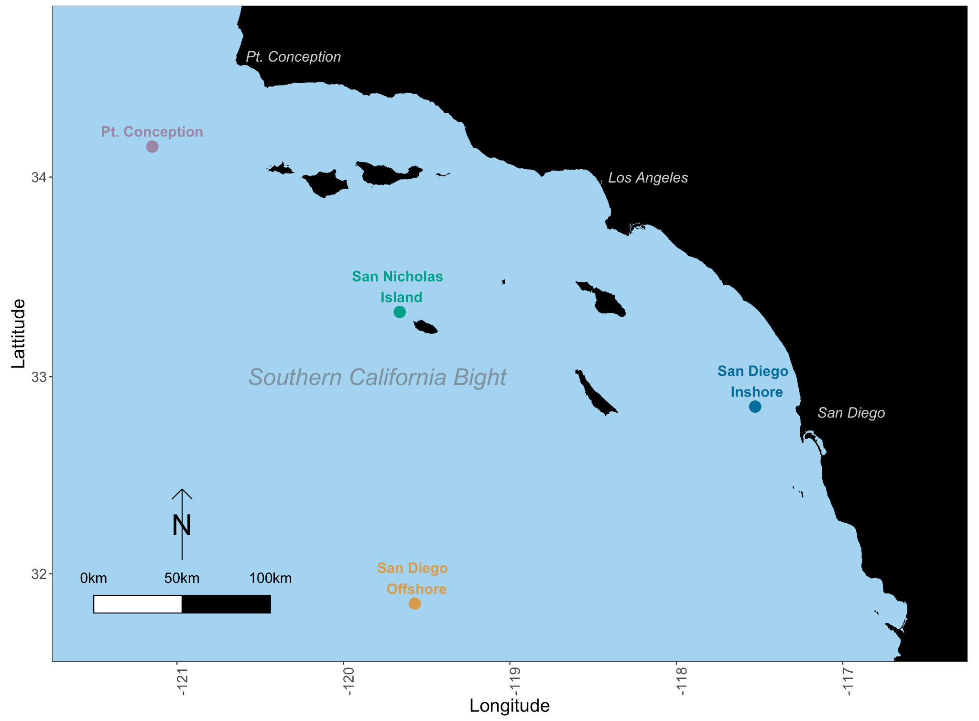

**Figure S1. station Map**

Ichthyoplankton samples were collected from four stations with distinct biogeographic characteristics.

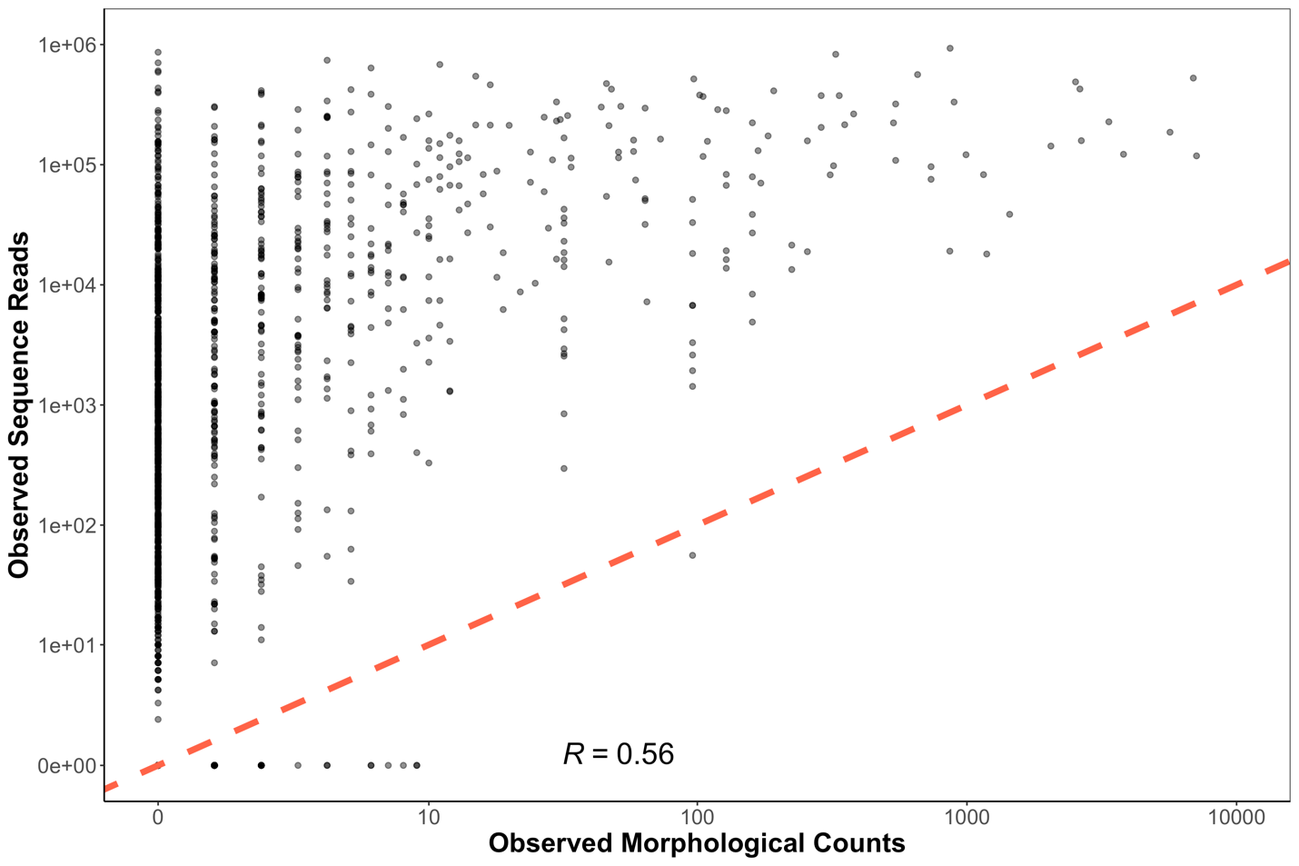

**Figure S2. Observed Sequence Reads vs. Observed Morphological Counts**

Observed sequencing reads and morphological counts do not follow a clear linear relationship. The one-to-one line is plotted in red and Pearson correlation coefficient is 0.56. This non-linearity is unsurprising given that observed reads are a function of both DNA concentrations (here assumed proportional to morphological counts) as well as species-specific amplification efficiencies (here are unknown) (See Supplement 2). Thus without accounting for species-specific amplification efficiencies within the compositional amplicon data set, we do not expect to observe a clear positive relationship. This apparent lack of relationship depicted here motivated the creation of the mechanistic joint Bayesian model. The occurrence of stochastic dropouts (technical replicates with zero reads) can be observed along the X-axis. Variance is highest at low observed morphological counts.

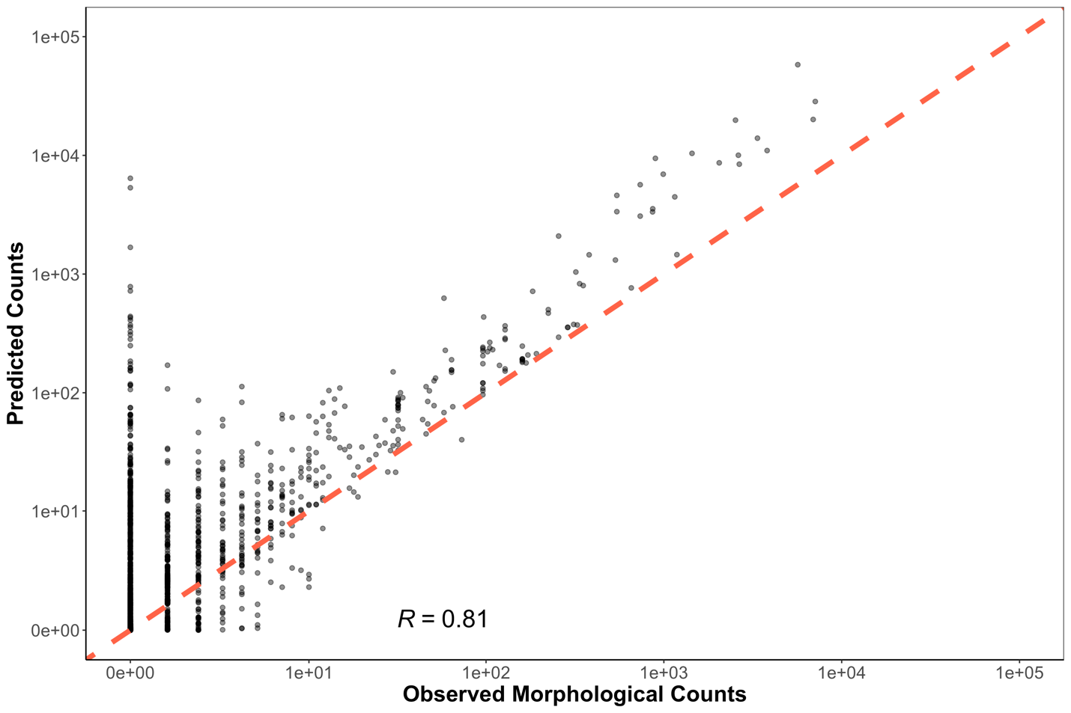

**Figure S3. Predicted Counts vs. Observed Morphological Counts**

Predicted counts are generated from the joint Bayesian model. The one-to-one line is plotted in red and Pearson correlation coefficient is 0.81. Variance in predicted counts markedly decreases with higher observed morphological counts. We note variance in predicted counts is substantially less than that between observed reads and morphological counts Figure S3.

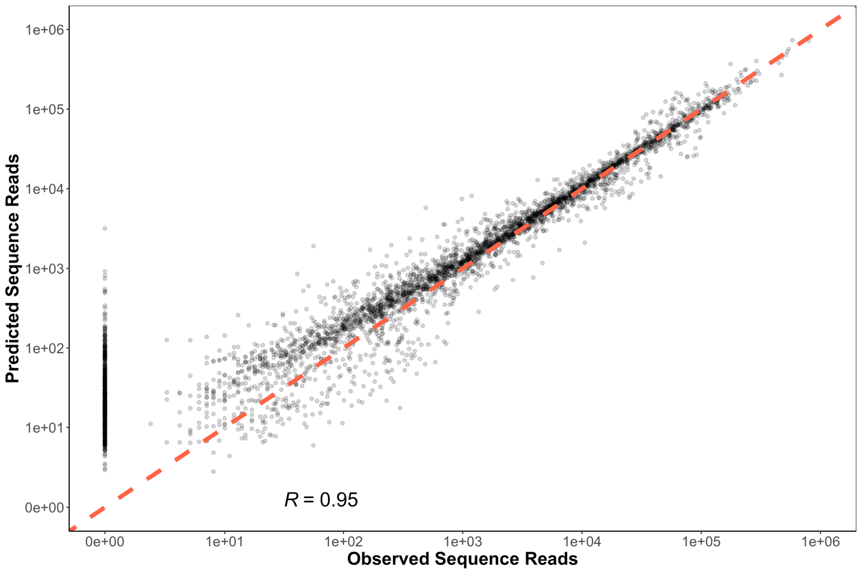

**Figure S4. Predicted Sequence Reads vs. Observed Sequence Reads**

Predicted sequence reads are generated from the joint Bayesian model. The one-to-one line is plotted in red and Pearson correlation coefficient is 0.95. In general, predicted sequence reads track observed sequence reads, and show substantially less variance than observed sequence reads in Figure S3. However, unexpected zeros across multiple technical PCR replicates (stochastic dropouts), deviate notably from expected, low variance results (points along Y-axis). We note that all observed stochastic dropouts occur in less than 2.9% of sample read proportions and less than 9 morphological counts for a given sample. Such dropouts are likely a function of subsampling rare DNA molecules associated with molecular biology processing (See Supplement 2).

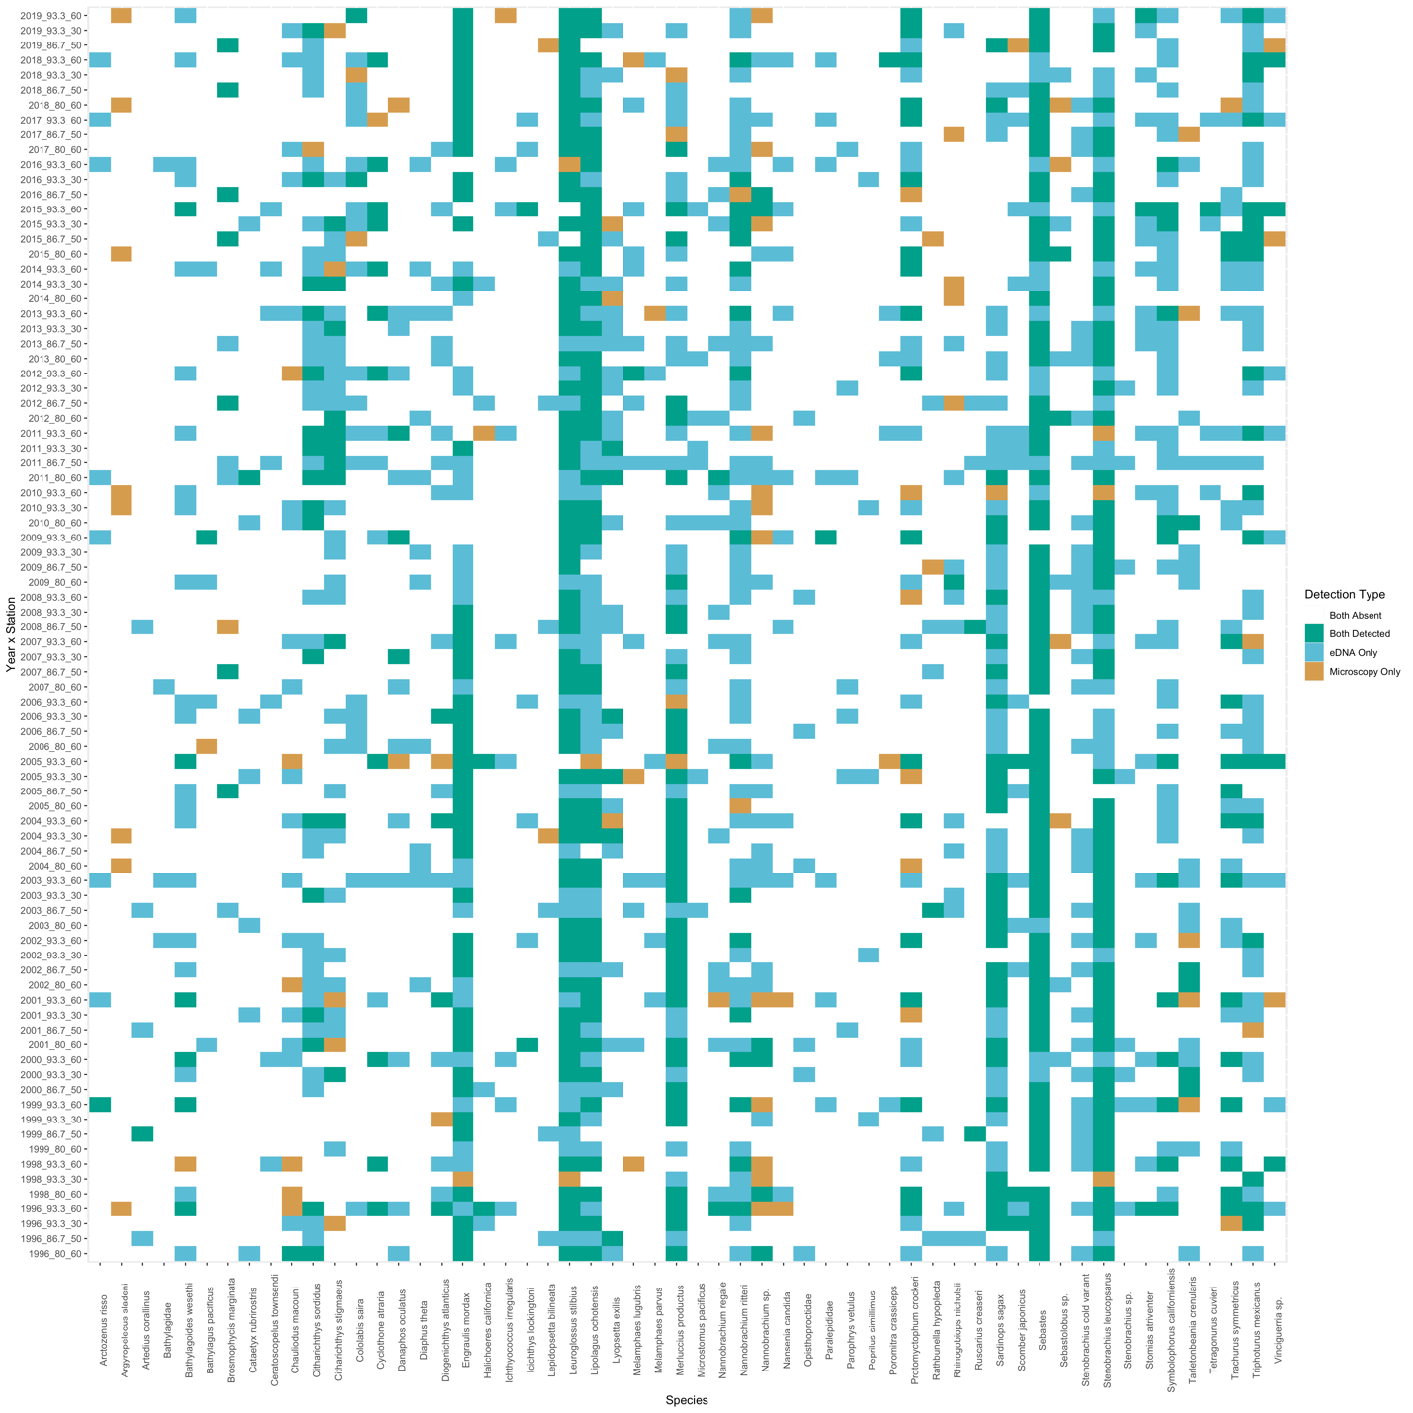**Figure S5. Co-detection of Taxa By Metabarcoding and Microscopy**

Of the 56 taxa used for modeling efforts (Supplemental Methods), both metabarcoding and microscopy detected 46 taxa, with nine detected only be metabarcoding and one detected only by microscopy.

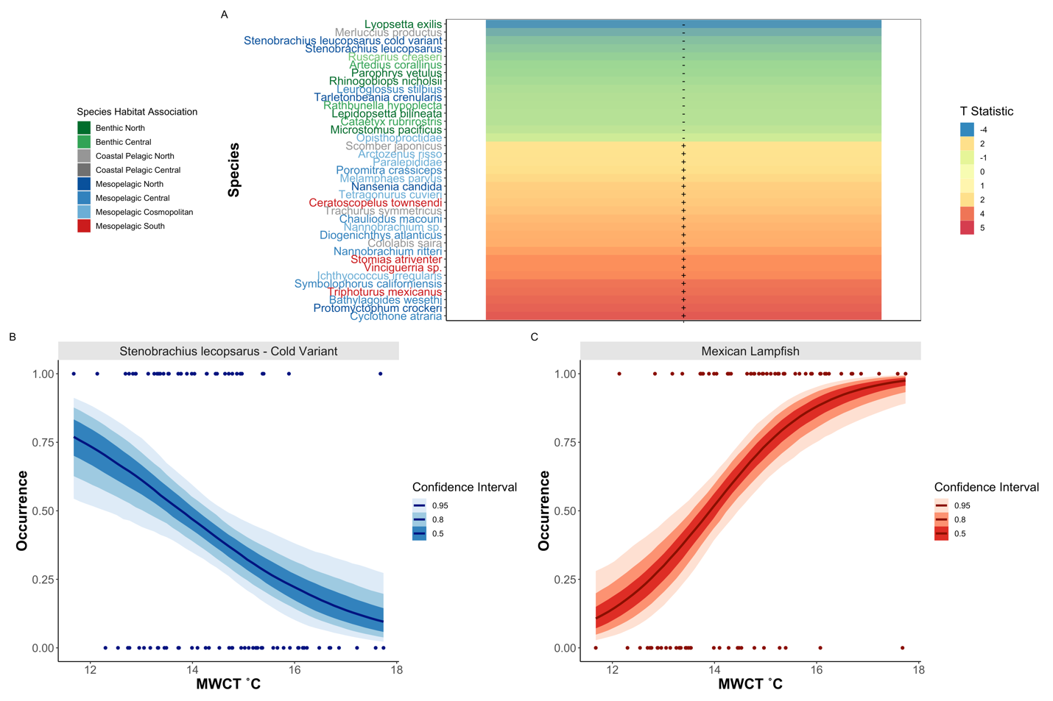

**Figure S6. Temperature Associations in Fish Species**

Changes in species occurrence patterns in response to MWCT, with Southern Mesopelagic species increasing in prevalence with elevated temperature (A). T statistic (slope coefficient/ standard error) from generalized binomial mixed model was calculated for each species across all stations. Only species with significantly different slopes (95% CI greater or less than zero) are plotted. Importantly, metabarcoding identified cold associated variants of the Northern Lanternfish (*Stennobrachius leucopsarus*) which cannot be morphologically identified (B) as well as warm-associated species like the Mexican Lampfish (*Triphoturus mexicanus*) (C).

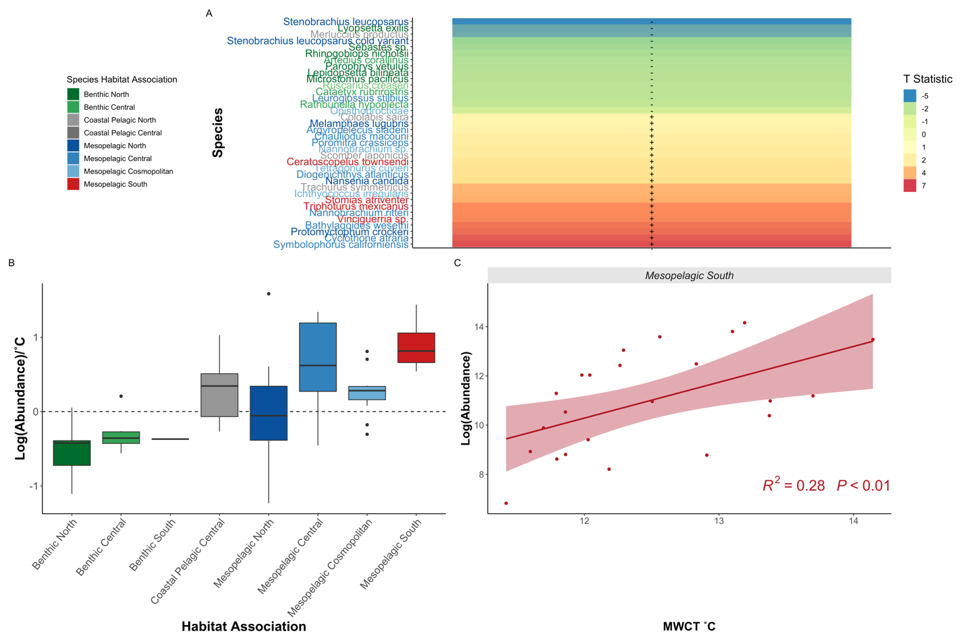

**Figure S7. Southern Oceanic Species Drive Fish Community Shifts**

We capture changes in species biomass in response to MWCT, with Southern Mesopelagic species increasing in abundance with elevated temperature (A). T statistic (slope coefficient/standard error) from generalized linear models were calculated for each species across all stations. Only species with significantly different slopes (95% CI greater or less than zero) are plotted. Southern mesopelagic fishes were associated with increased temperature as indicated by the boxplots of all species-specific slopes from generalized linear models (B) and by the aggregated abundance relationship (C). In contrast, benthic species, as well as Northern Hake and Pacific Sardine abundances, were correlated with cooler temperatures.

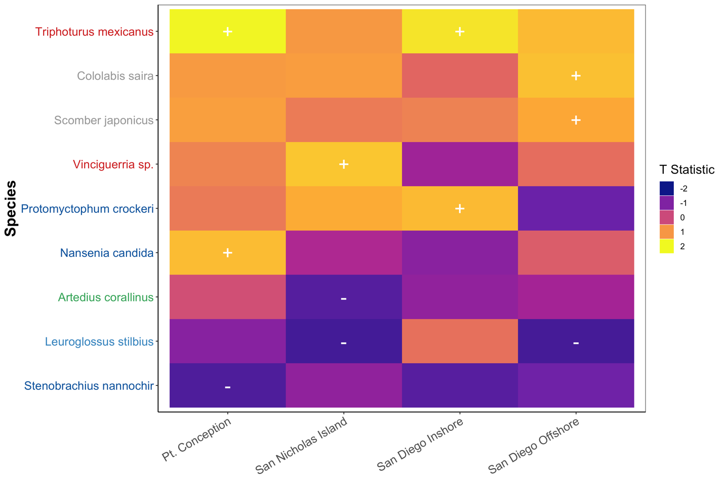

**Figure S8. Significant Species Occurrence and SST Correlations at each Station**

Occurrence of the Mexican lampfish (*Triphoturus mexicanus*)was positively correlated with increased SST at the three northernmost stations. Generalized binomial mixed model of occurrence versus SST was calculated for each species at each station. Only species with significantly different slopes (95% CI greater or less than zero) are plotted. Colors correspond to T statistic (slope coefficient/ standard error). Colors of species names correspond to habitat associations described in Figure 2.

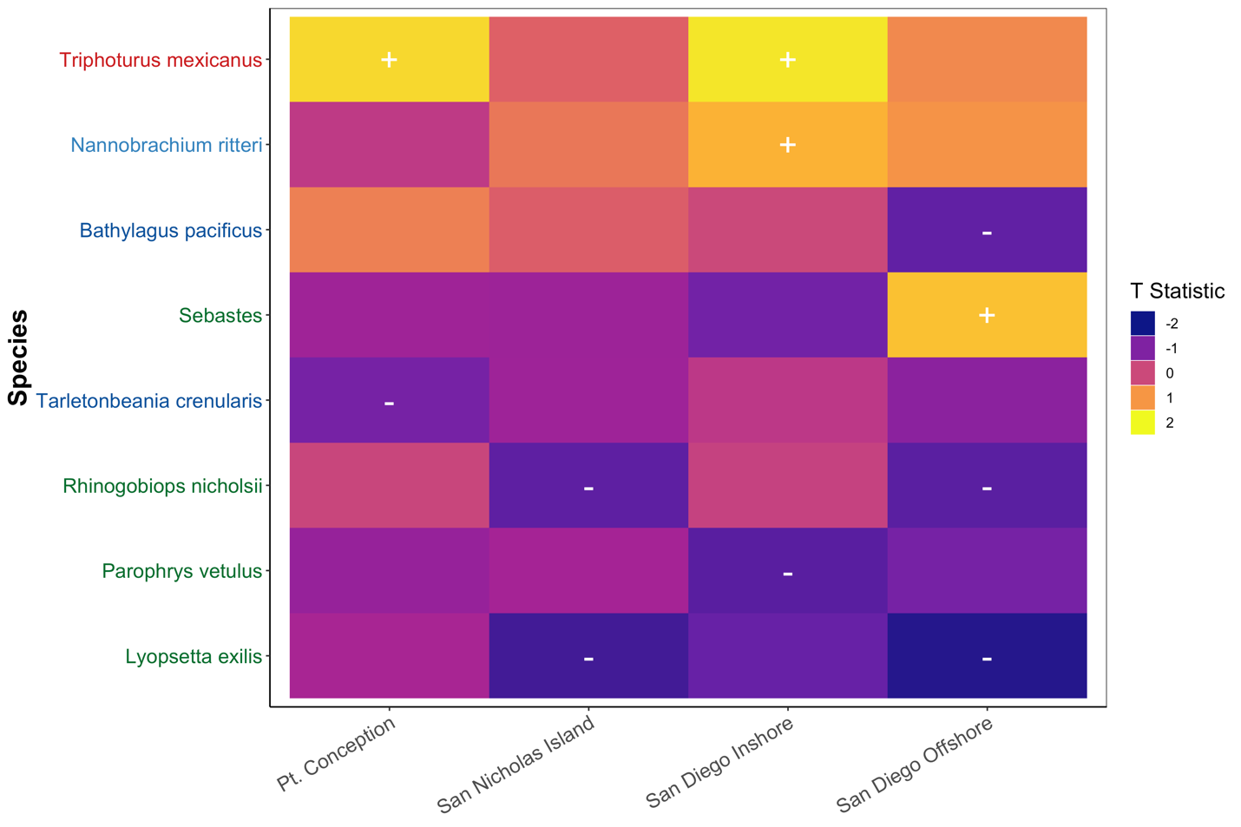**Figure S9. Significant Species Occurrence and MWCT Correlations at each Station**

Occurrence of the Mexican lampfish (*Triphoturus mexicanus*)was positively correlated with increased MWCTat the three northernmost stations. Generalized binomial mixed model of occurrence versus MWCTwas calculated for each species at each station. Only species with significantly different slopes (95% CI greater or less than zero) are plotted. Colors correspond to T_statistic (slope coefficient/ standard error). Colors of species names correspond to habitat associations described in Figure 2.

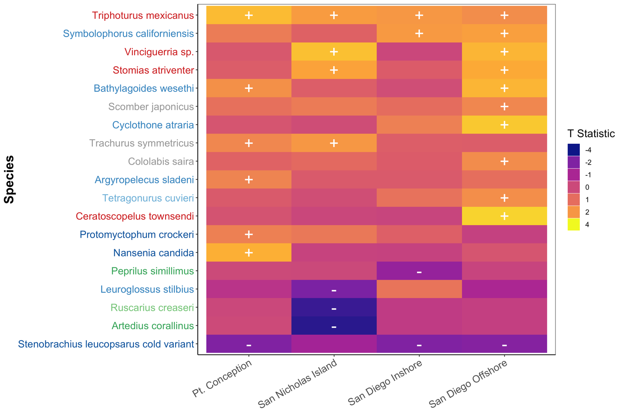**Figure S10. Significant Species Abundance and SST Correlations at each station**

The bbundance of the Mexican lampfish (*Triphoturus mexicanus*)was positively associated with increased SST at all stations. Likewise, the abundance of suite of mesopelagic species including *Vinciguerria* sp., *Symbolophorus californiensis,* and *Stomias atriventer* among others increased with warmer SST. Generalized linear mixed model of log (abundance) versus SST was calculated for each species at each station. Only species with significantly different slopes (95% CI greater or less than zero) are plotted. Colors correspond to T statistic (slope coefficient/ standard error). Colors of species names correspond to habitat associations described in Figure 2.

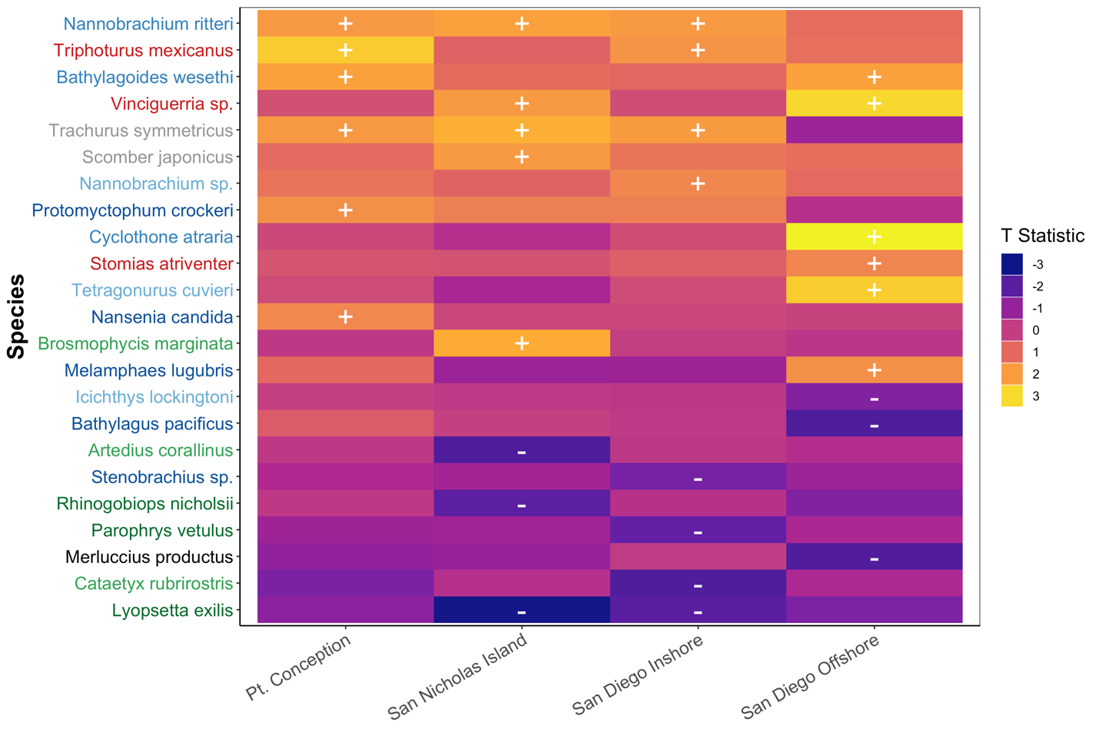**Figure S11. Significant Species Abundance and MWCT Correlations at each station**

The abundance of the Mexican lampfish (*Triphoturus mexicanus*)was positively associated with increased MWCTat all stations. Likewise, the abundance of suite of mesopelagic species including *Vinciguerria* sp., *Symbolophorus californiensis,* and *Stomias atriventer* among others increased with warmer SST. Generalized linear mixed model of log (abundance) versus MWCTwas calculated for each species at each station. Only species with significantly different slopes (95% CI greater or less than zero) are plotted. Colors correspond to T statistic (slope coefficient/ standard error). Colors of species names correspond to habitat associations described in Figure 2.

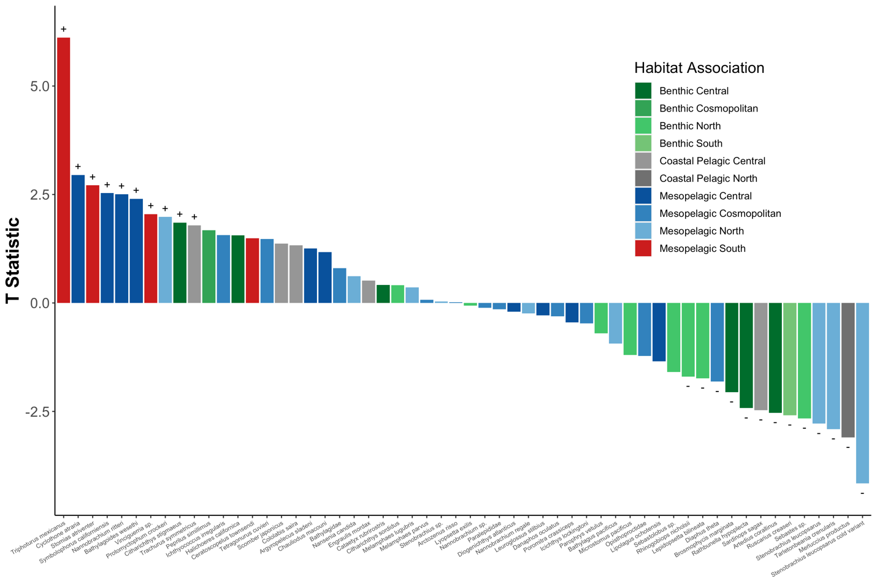

**Figure S12.** **Bar Plot** **of Significant Species Abundance and SST Correlations Across All stations**

The abundance of southern mesopelagic species increased with warmer temperatures while fisheries targets like Pacific Sardine (*Sardinops sagax*) and North Pacific Hake (*Merluccius productus*) decreased. Generalized linear mixed model of log (abundance) versus SST was calculated for each species across all stations. Only species with significantly different slopes (95% CI greater or less than zero) are plotted. Colors correspond to T statistic (slope coefficient/ standard error).

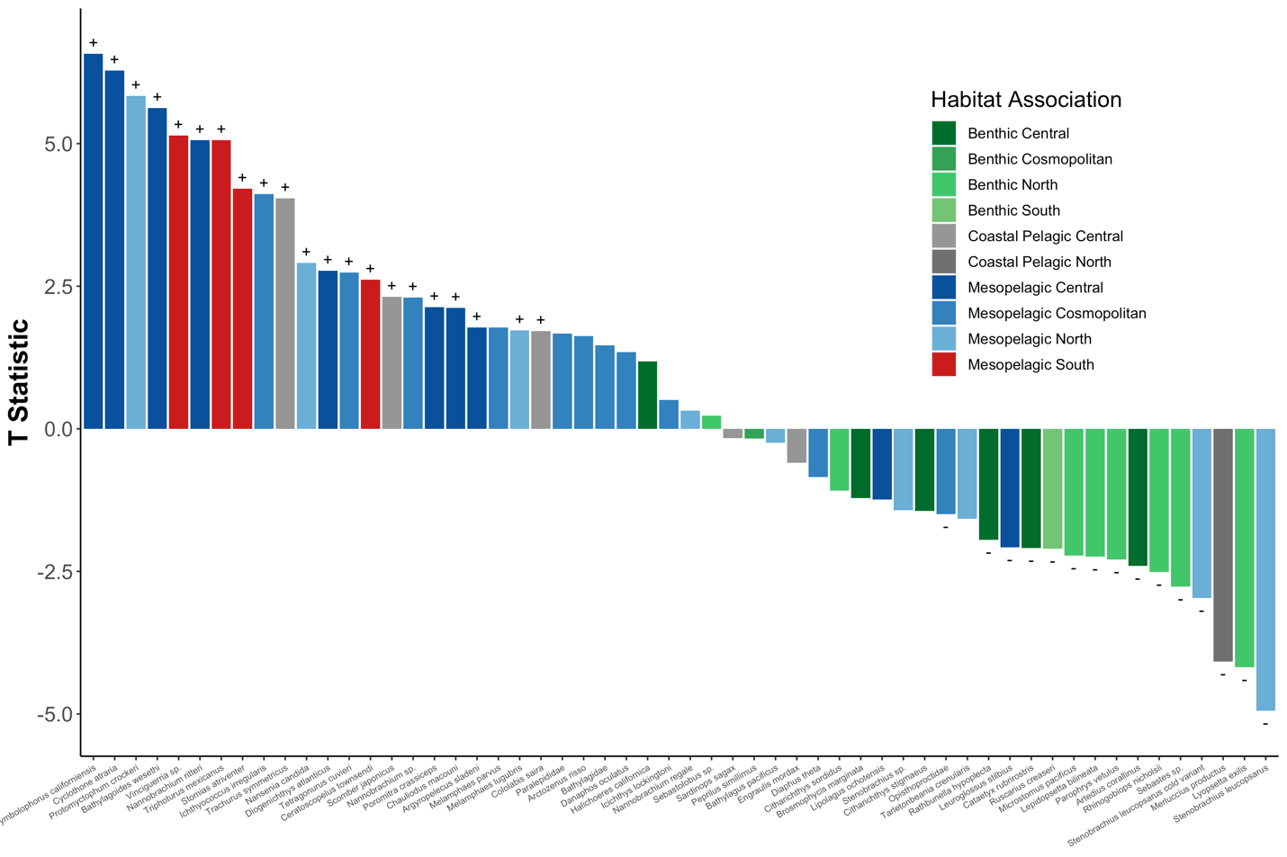

**Figure S13.** **Bar Plot** **of Significant Species Abundance and MWCT Correlations Across All stations**

The abundance of southern mesopelagic species increased with warmer temperatures while fisheries targets like Pacific Sardine (*Sardinops sagax*) and North Pacific Hake (*Merluccius productus*) decreased. Generalized linear mixed model of log (abundance) versus SST was calculated for each species across all stations. Only species with significantly different slopes (95% CI greater or less than zero) are plotted. Colors correspond to T statistic (slope coefficient/ standard error).

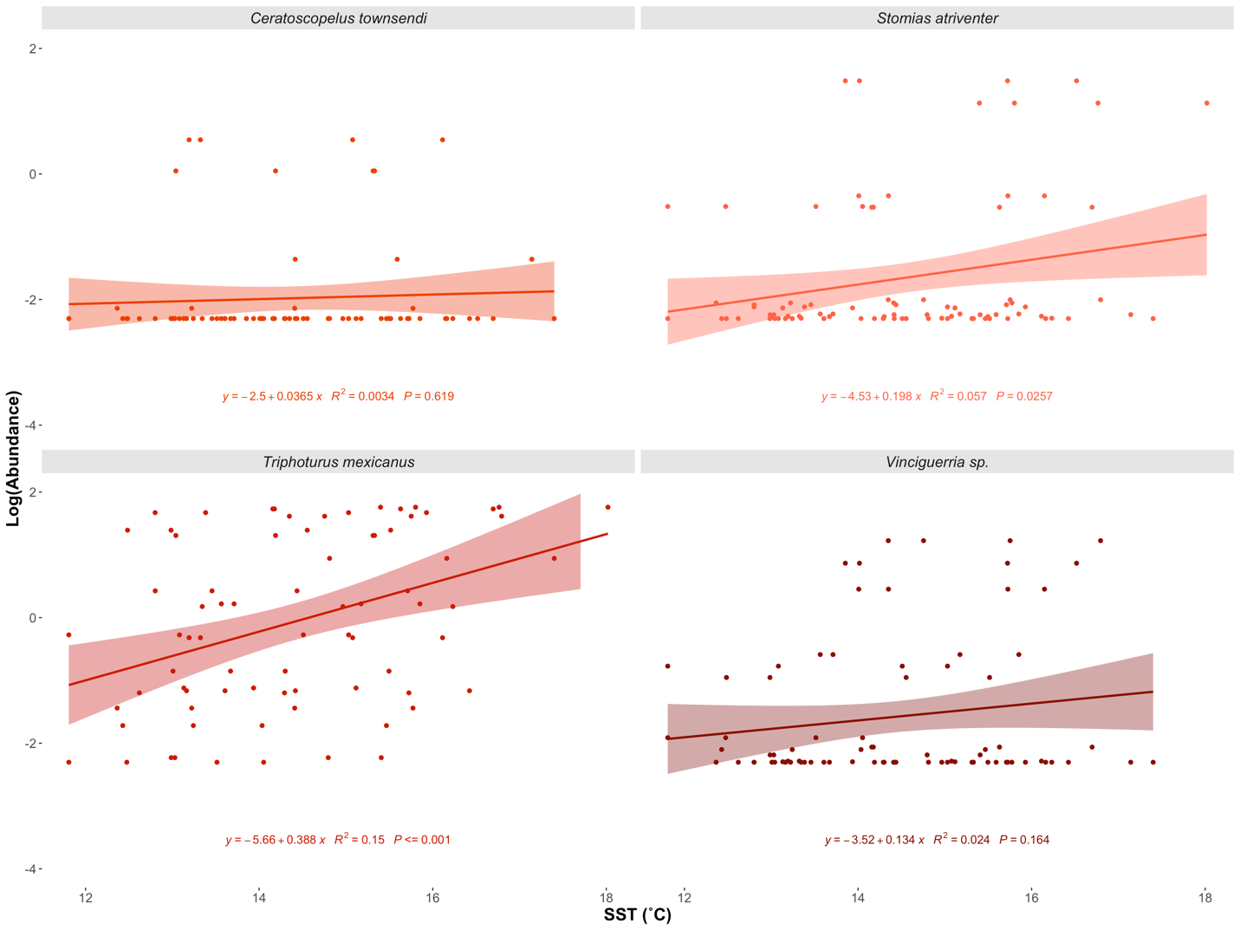

**Figure S14. Increased Abundance of Southern Mesopelagic Species with Higher SST**

Species specific regressions of log (Abundance) vs. SST (˚C). Three of the four southern mesopelagic species had significant positive associations between abundance and SST. Although not significant across all stations, the abundance of *Ceratoscopelus townsendi* significantly increased with higher SST at the San Diego Offshore station (Figure S7).

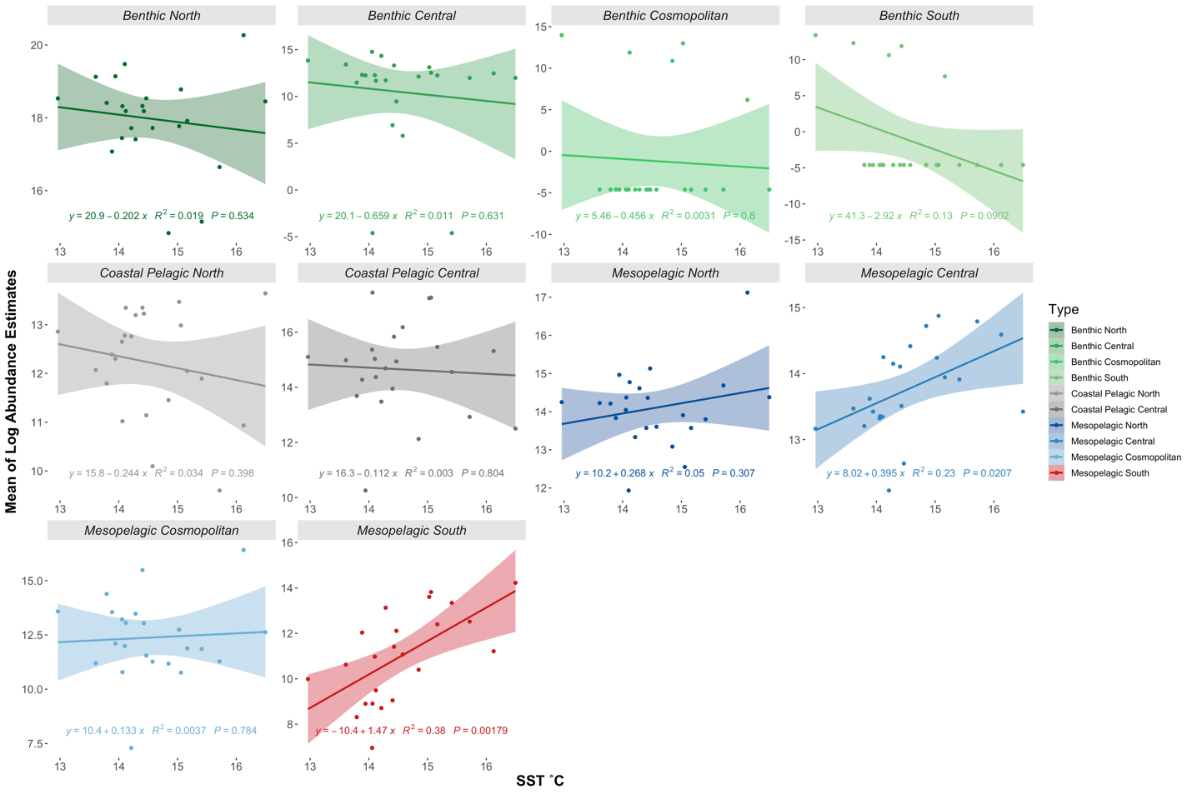

**Figure S15. Increased Abundance of Southern and Central Mesopelagic Species with Higher SST**

Abundances of each habitat association were summed at each station. Habitat association regressions were fit using sum total log (Abundance) vs. SST (˚C).

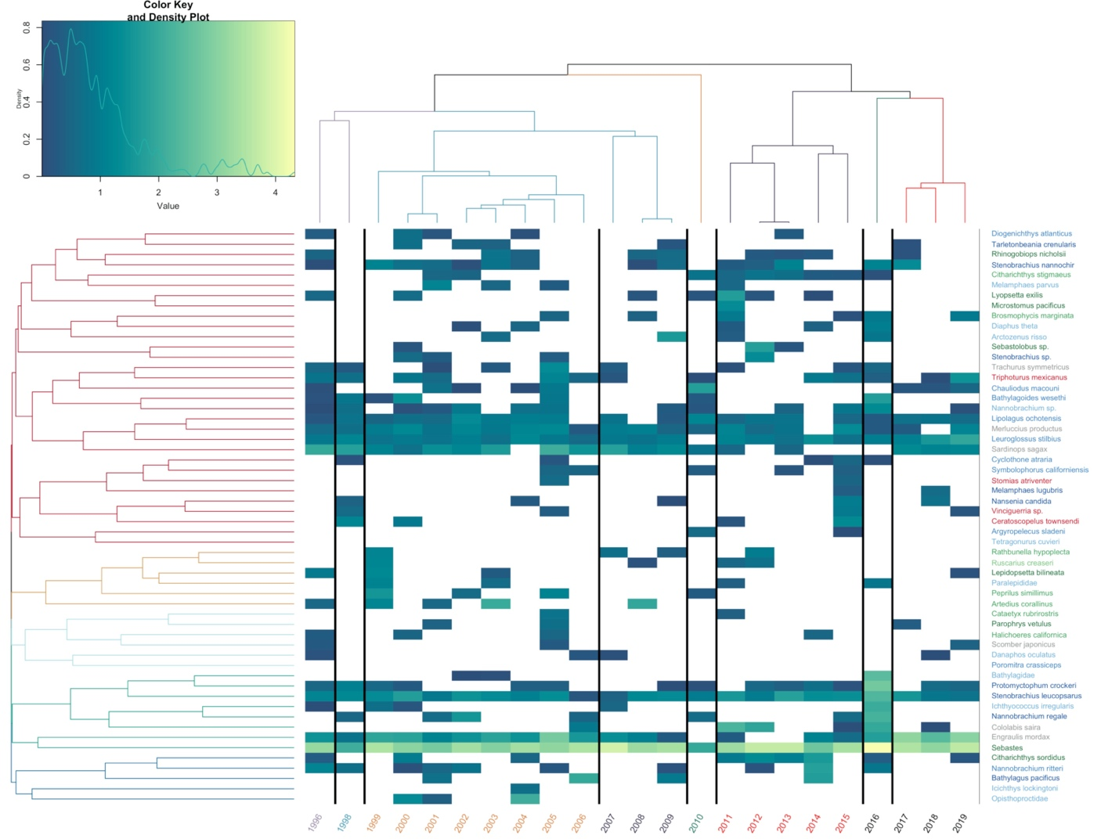

**Figure S16. Heat Map of Abundances Over Time**

Northern Anchovy (*Engraulis* mordax) and rockfishes *Sebastes* sp. dominated predicted counts. Estimated abundance of each year, averaged across stations, plotted over time. Years are color coded by chronological clustering. Species are grouped by hierarchical clustering. Lighter colors indicate higher abundance, white is a lack of detection. Species are color coded by habitat association matching Figure 1.

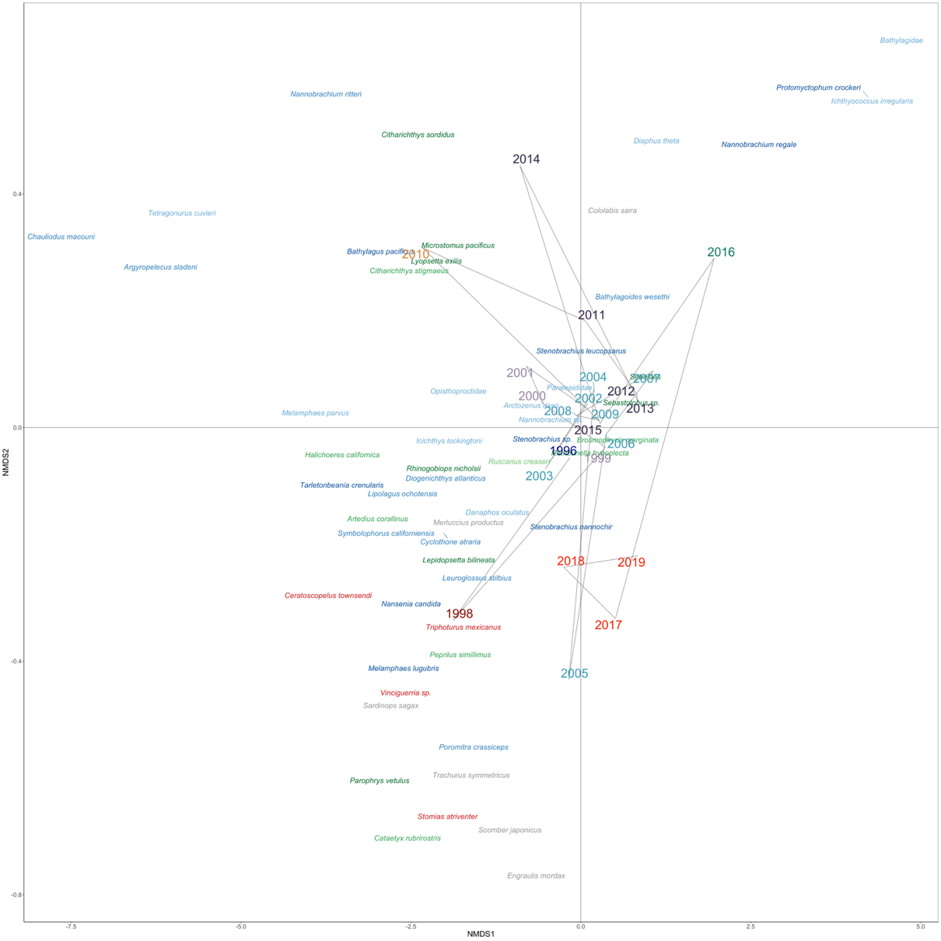

**Figure S17. NMDS Ordination of Species and Years**

Fish assemblages changed across time with southern mesopelagics clustering with the 1998 and 2005 El Niños as well as 2017-2019 after the peak of the marine heat wave. NMDS Ordination of Bray-Curtis dissimilarities calculated from summed abundance of each year averaged across stations. Marine heatwave patterns are obscured by differential onset and receding of the warming event across stations. Years are color coded by chronological clustering (k =8). Species are color coded by habitat association matching Figure 2.

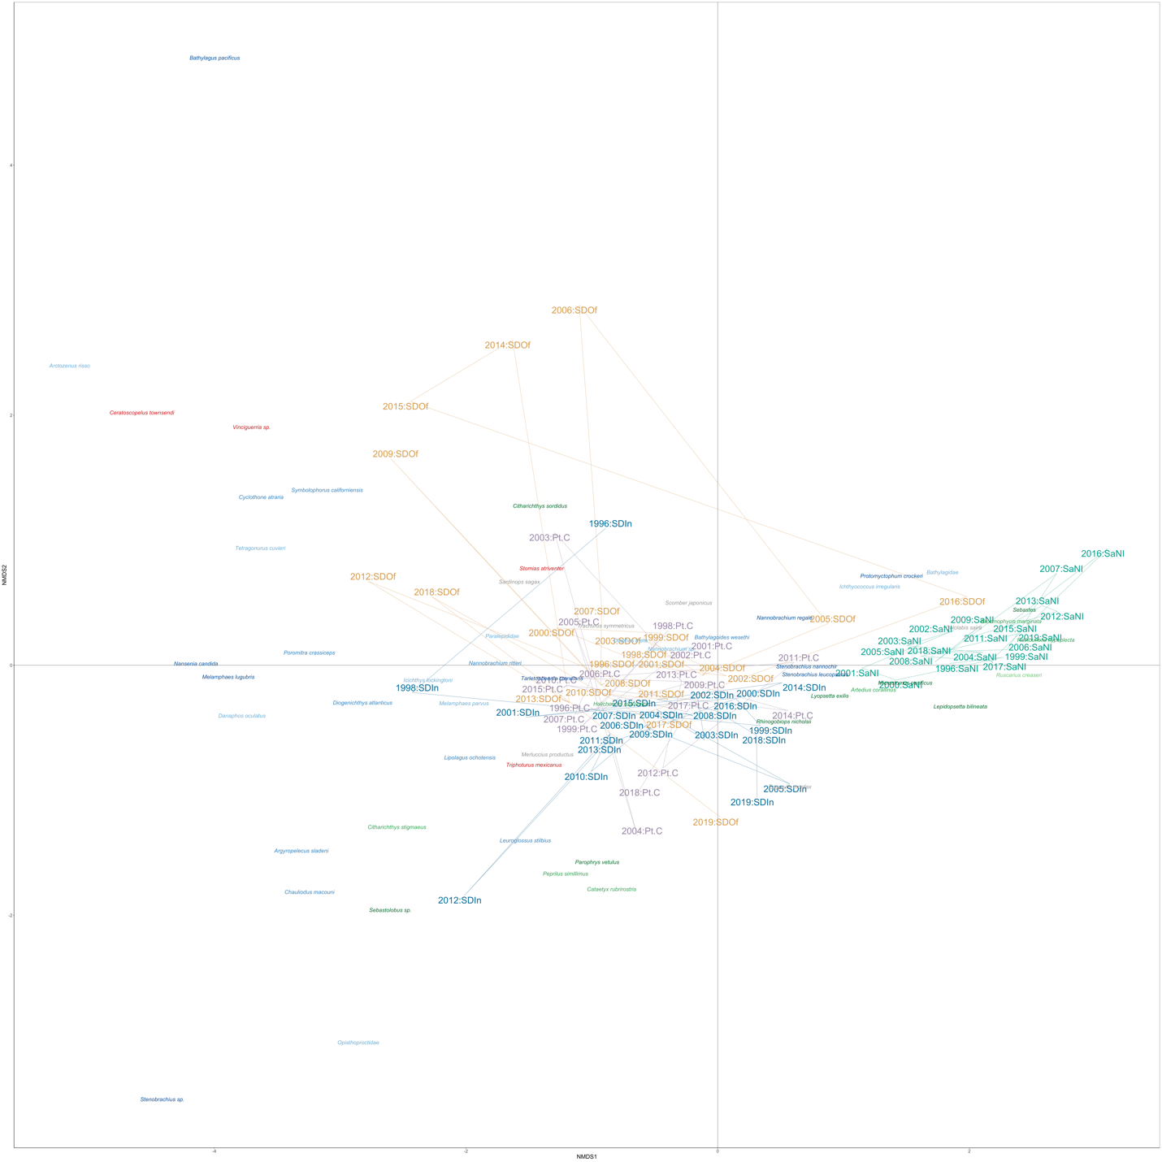

**Figure S18. NMDS Ordination of Species and Samples**

Fish assemblages were strongly structured by stations, particularly the San Nicholas Island station which had the highest abundance of *Sebastes* sp. NMDS Ordination of Bray-Curtis dissimilarities calculated from the abundance of each year and station. Samples are color coded by station. Species are color coded by habitat association matching Figure 2.

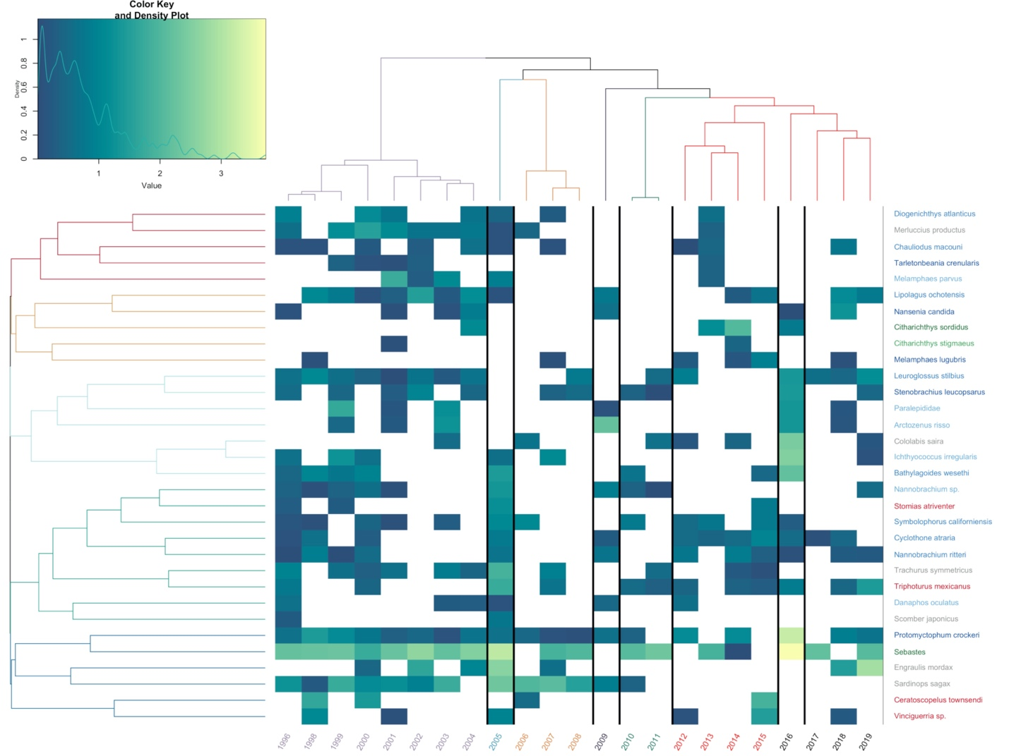

**Figure S19. Heat Map of San Diego Offshore Abundances Over Time**

Estimated abundance of each year plotted over time. Years are color coded by chronological clustering. Species are grouped by hierarchical clustering. Lighter colors indicate higher abundance, white is a lack of detection. Species are color coded by habitat association matching Figure 1.

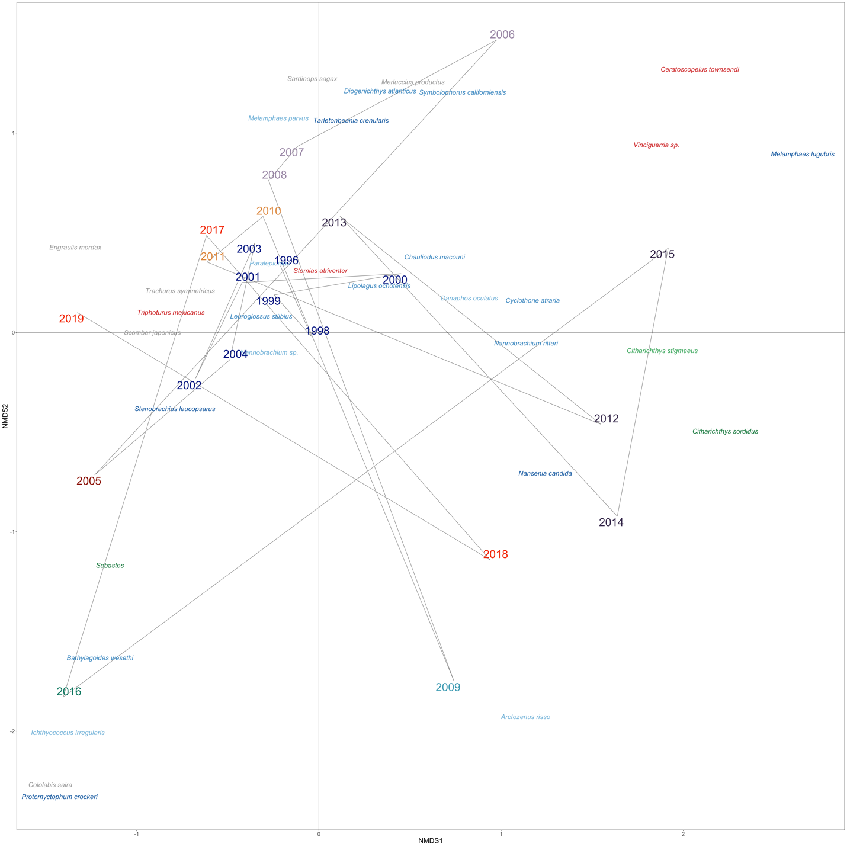

**Figure S20. NMDS Ordination of San Diego Offshore Species and Years**

NMDS Ordination of Bray-Curtis dissimilarities calculated from abundance of each year. Years are color coded by chronological clustering (k =8). Species are color coded by habitat association matching Figure 2.

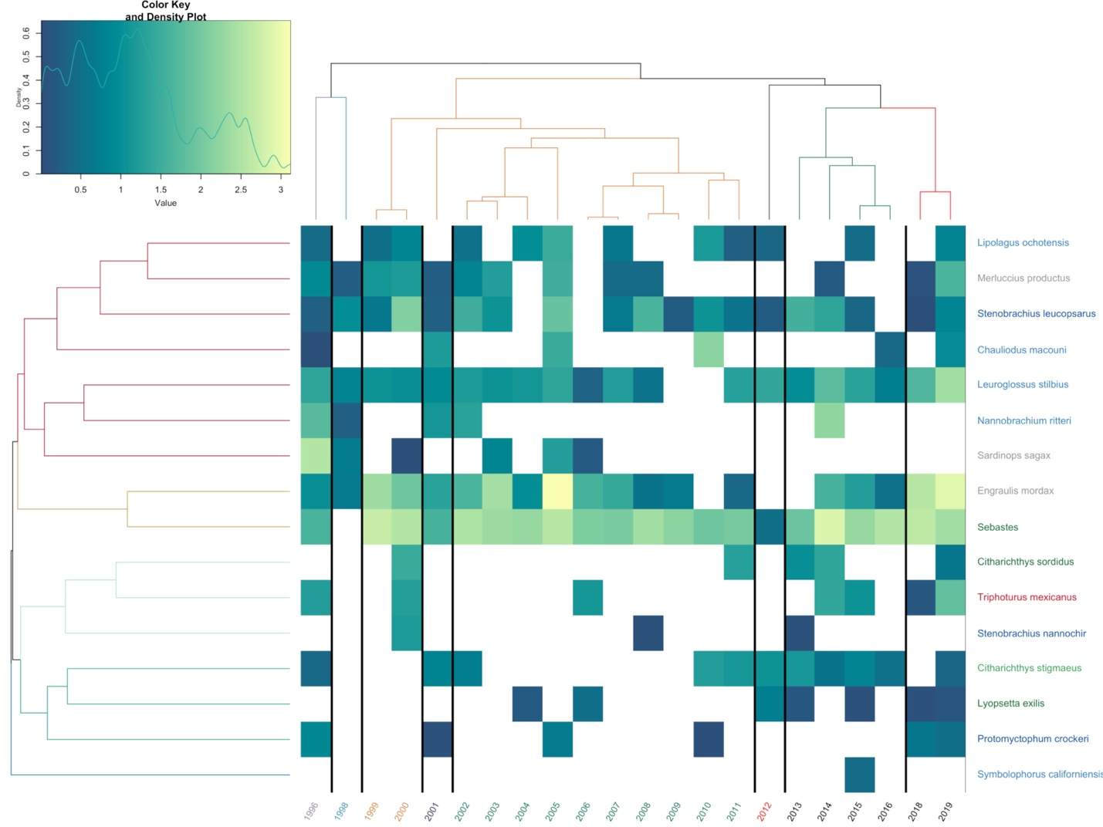

**Figure S21. Heat Map of San Diego Inshore Abundances Over Time**

Estimated abundance of each year plotted over time. Years are color coded by chronological clustering. Species are grouped by hierarchical clustering. Lighter colors indicate higher abundance, white is a lack of detection. Species are color coded by habitat association matching Figure 1.

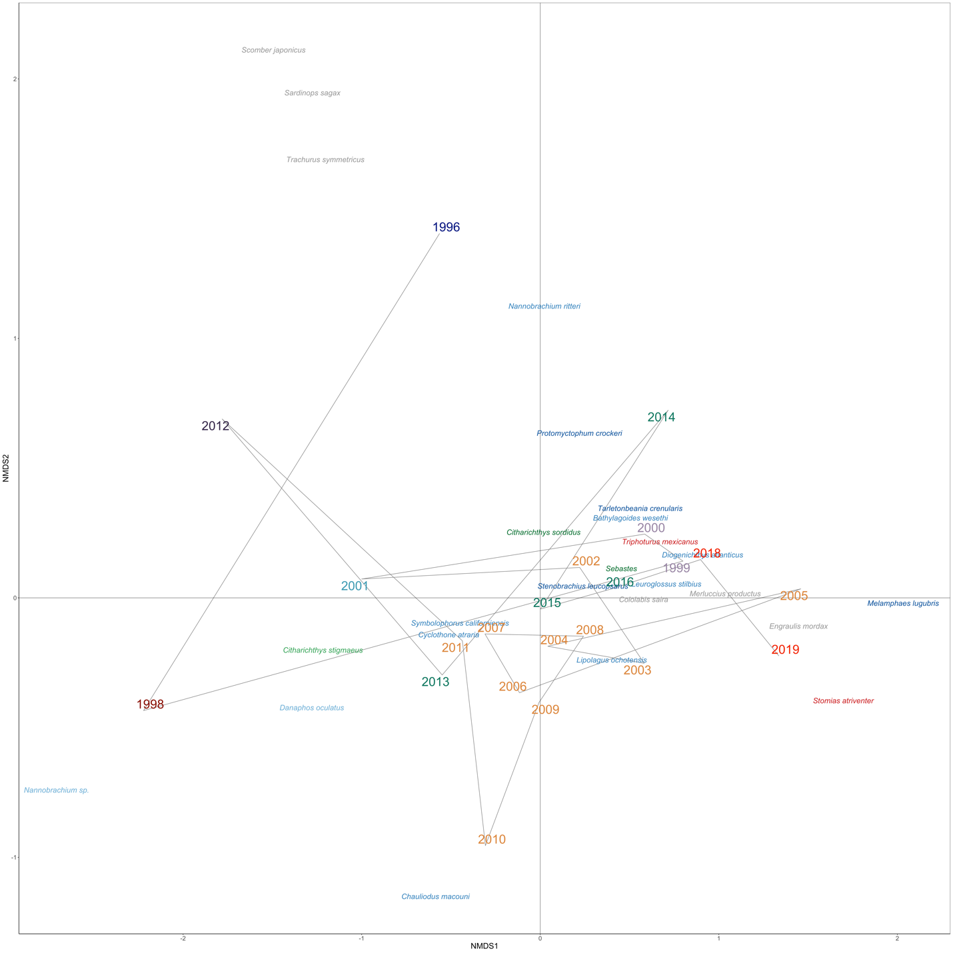**Figure S22. NMDS Ordination of San Diego Inshore Species and Years**

NMDS Ordination of Bray-Curtis dissimilarities calculated from abundance of each year. Years are color coded by chronological clustering (k =8). Species are color coded by habitat association matching Figure 2.

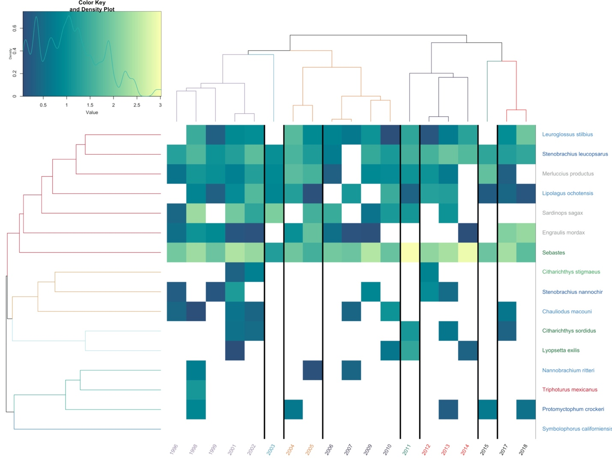

**Figure S23. Heat Map of Pt. Conception Abundances Over Time**

Estimated abundance of each year plotted over time. Years are color coded by chronological clustering. Species are grouped by hierarchical clustering. Lighter colors indicate higher abundance, white is a lack of detection. Species are color coded by habitat association matching Figure 1.

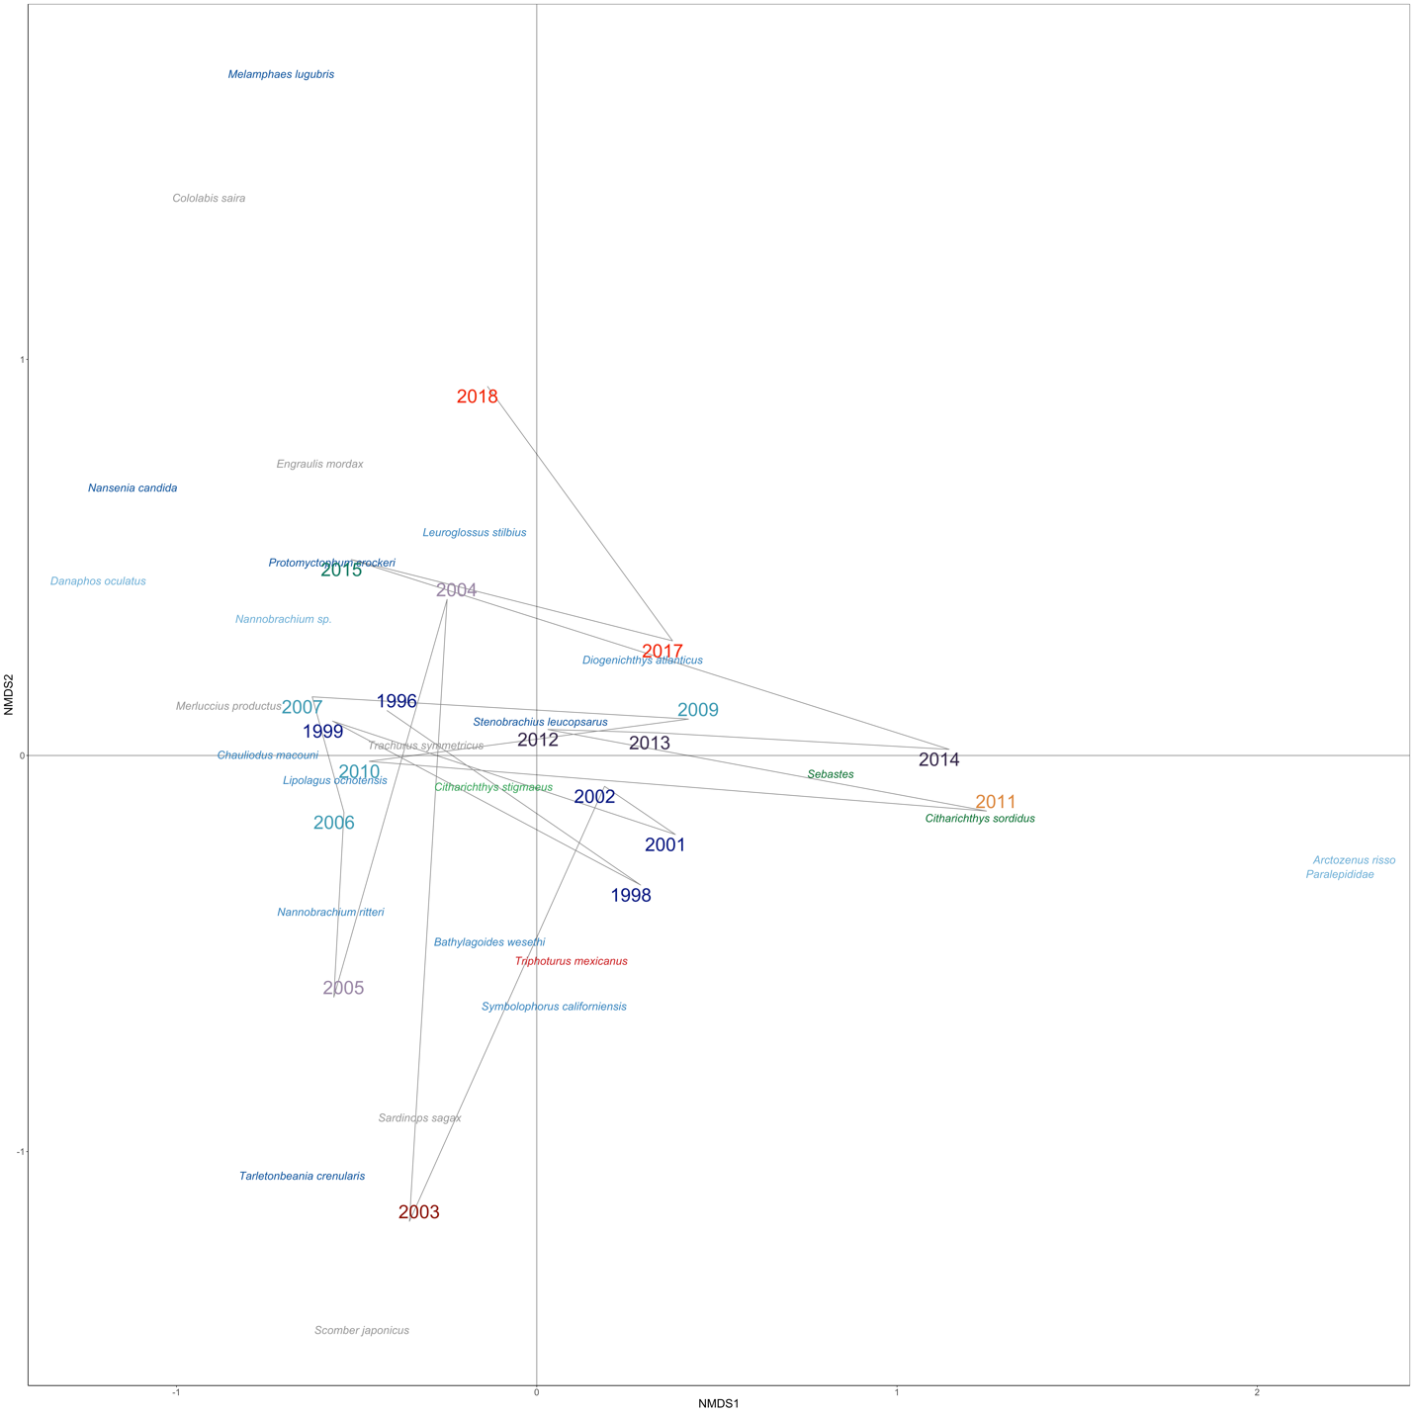

**Figure S24. NMDS Ordination of Pt. Conception Species and Years**

NMDS Ordination of Bray-Curtis dissimilarities calculated from abundance of each year. Years are color coded by chronological clustering (k =8). Species are color coded by habitat association matching Figure 2.

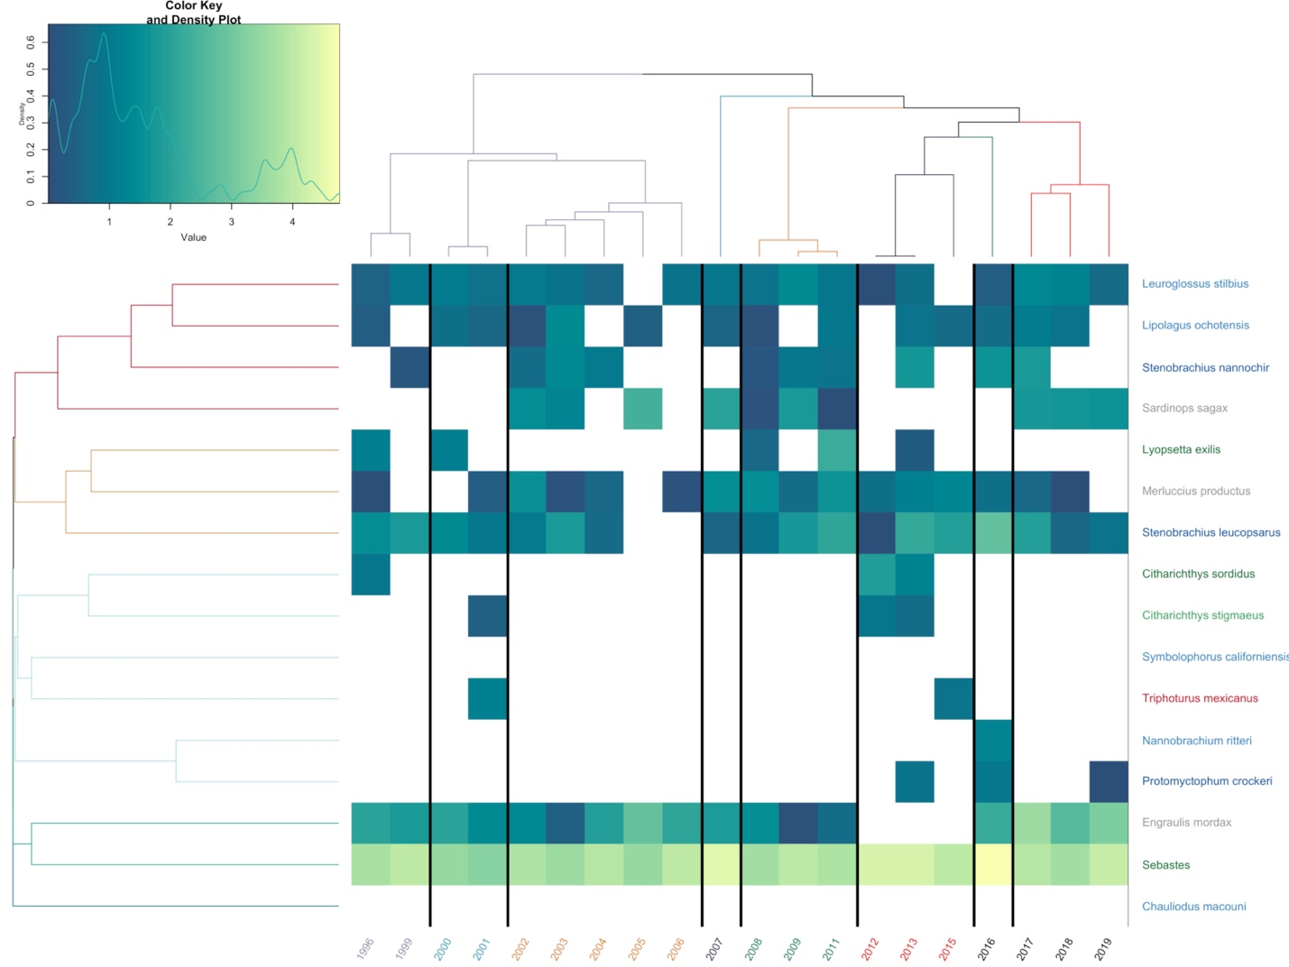

**Figure S25. Heat Map of San Nicholas Island Abundances Over Time**

Estimated abundance of each year plotted over time. Years are color coded by chronological clustering. Species are grouped by hierarchical clustering. Lighter colors indicate higher abundance, white is a lack of detection. Species are color coded by habitat association matching Figure 1.



**Figure S26. NMDS Ordination of San Nicholas Island Species and Years**

NMDS Ordination of Bray-Curtis dissimilarities calculated from abundance of each year. Years are color coded by chronological clustering (k =8). Species are color coded by habitat association matching Figure 2.

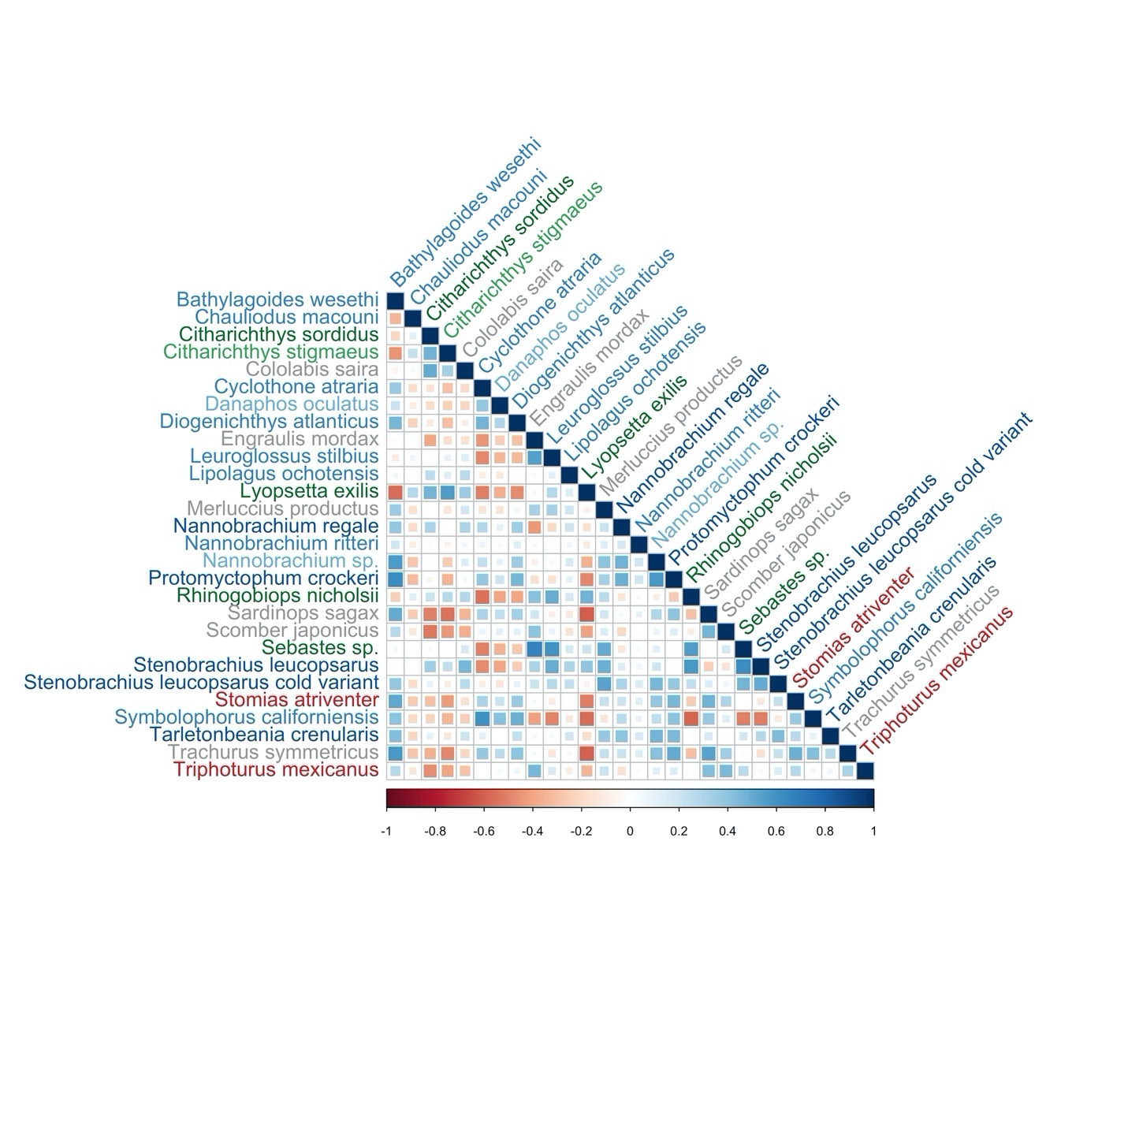

**Figure S27. Co-occurrence Patterns of Species Controlling for SST**

Benthic fisheries targets like sanddabs were negatively correlated with mesopelagic species when controlling for SST. These results capture a strong benthic vs. pelagic community dynamics when controlling for SST. We plot the correlation matrix of the generalized linear latent variable model predictors across species. Species in blue correlate are positively correlated with each other while species in red are negatively correlated. Strength of association is visualized by size of square. Species are color coded by habitat association matching Figure 2.

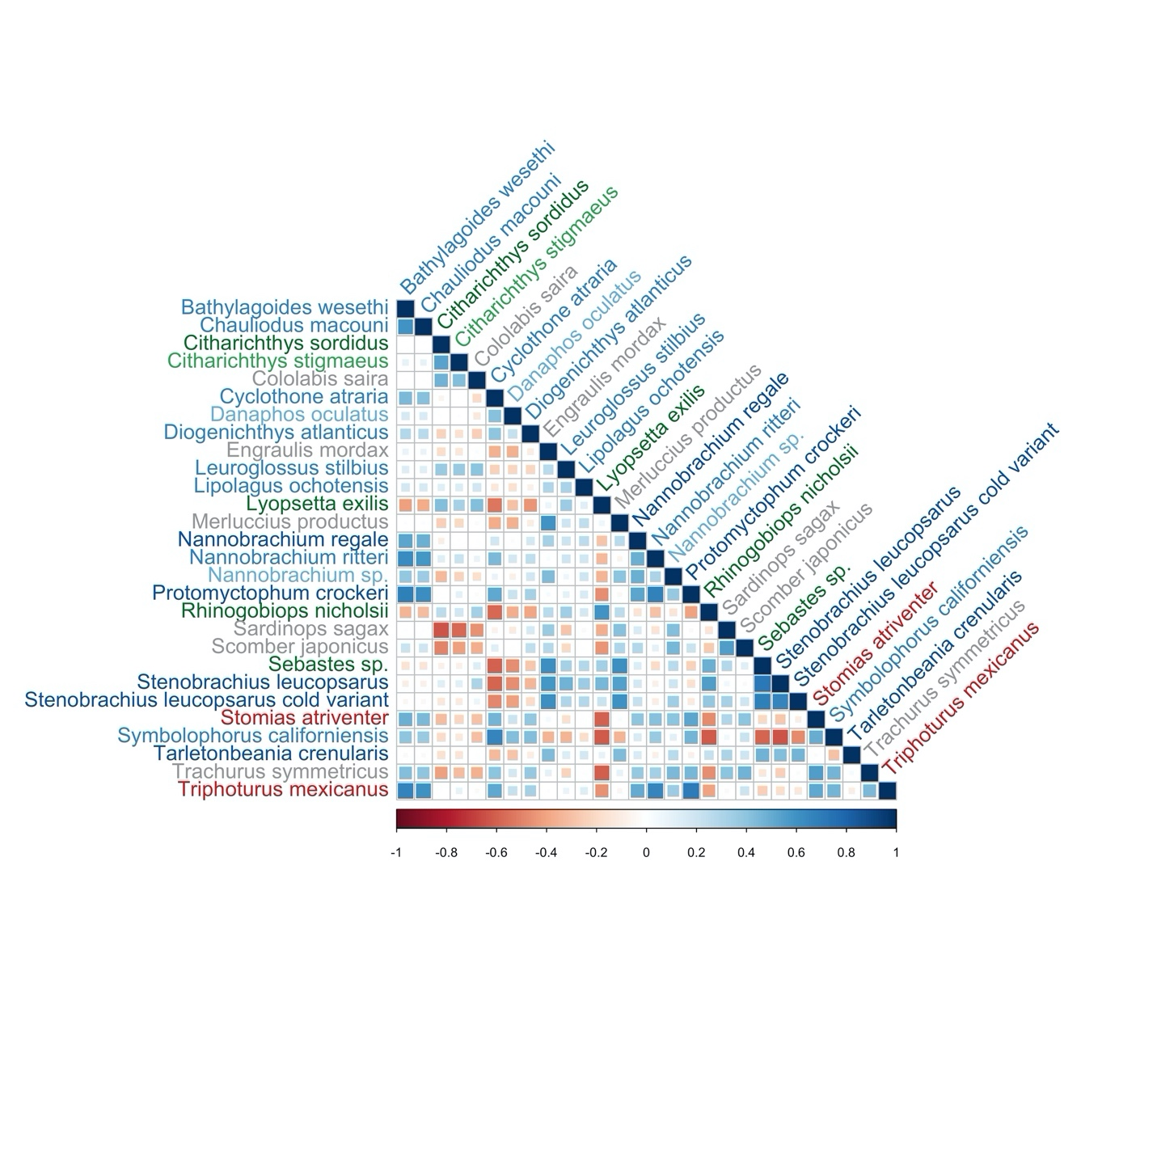

**Figure S28. Co-occurrence Patterns of Species**

Fisheries targets like North Pacific Hake were negatively correlated with mesopelagic species. We plot the correlation matrix of the generalized linear latent variable model predictors across species. Species in blue correlate are positively correlated with each other while species in red are negatively correlated. Strength of association is visualized by size of square. Species are color coded by habitat association matching Figure 2.

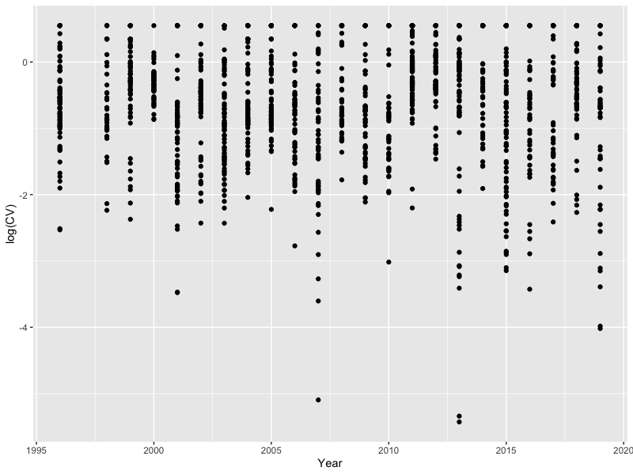

**Figure S29. Stable Precision of Amplicon Abundance Over Time**

Here we measure the coefficient of variation (CV) of species-specific amplicons across three technical replicates. An increase in CV with the age of the sample would signal degradation; we see no such trend.

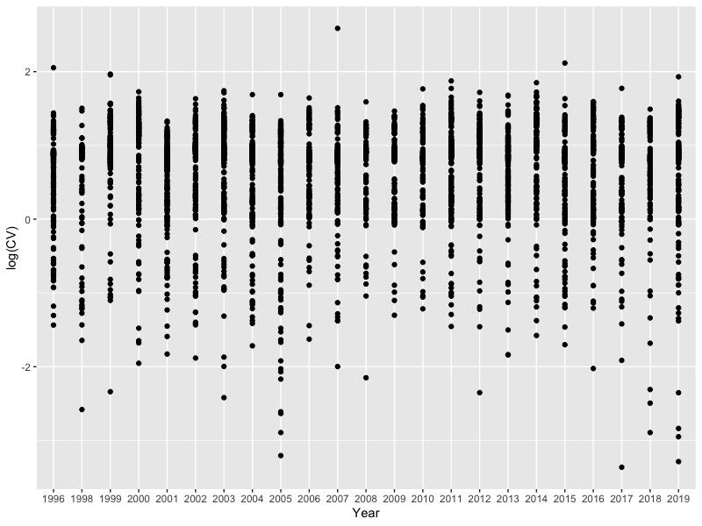

**Figure S30. Stable Precision of Abundance Estimates Over Time**

Coefficient of variation of model estimates of abundance over time. We observe no evidence of change in precision over time.